研究报告
Research Report
AtATH1转录活性研究及与AtOFP1蛋白互作的免疫共沉淀分析
Analysis of ATH1 Transcription Activity and Co-IP of ATH1 Protein Interaction with OFP1
张利国^{1,2*} 张效霏¹ 王贵江¹ 张树权¹ 常缨²
Zhang Liguo ^{1,2*} Zhang Xiaofei¹ Wang Guijiang ¹ Zhang Shuquan ¹ Chang Ying ²
1黑龙江省农业科学院, 哈尔滨, 150086; 2东北农业大学, 哈尔滨, 150038
1 Heilongjiang Academy of Agricultural Sciences, Harbin, 150086, China
2 Northeast Agricultural University, Harbin, 150038, China
*通信作者, zlg86@aliyun.com
* Corresponding author, zlg86@aliyun.com
摘 要 ATH1在植物生长发育过程中具有多方面的重要调节功能，并可能通过与多效的转录调节因子OFP1蛋白互作来调控植株发育的重要性状，然而，目前ATH1与OFP1的互作并没有被进一步的证实，且ATH1的转录活性并没有被确定。本研究采用原生质体瞬时转染的方法与免疫共沉淀分析来确定ATH1与OFP1的蛋白互作关系及ATH1的转录活性，结果表明在体内能够形成ATH1-OFP1蛋白复合物，且ATH1为转录抑制因子，OFP1能够加强ATH1的转录抑制活性。针对植物发育过程中的调节功能，本研究更能为明确OFP和OFPs-TALE蛋白复合物，提供分子方面的研究基础，对植物重要性状的遗传改良具有重要意义。
关键词 ATH1; 转录活性; 蛋白互作; 免疫共沉淀
Abstract ATH1 has multifaceted functions in regulating growth and development, and possibly regulate development by interacting with OFP1 protein. However, the protein interaction of ATH1 with OFP1 has not been further confirmed, and the transcription activity of ATH1 has not been determined. In this work, the interaction ATH1 with OFP1 was further confirmed by using Co-IP, and the transcription activity of ATH1 was determined by using Protoplast transfection system. The results showed that the ATH1-OFP1 protein complexes could be formed in vivo, and ATH1 was a transcription inhibitory factor, and OFP1 could enhance the transcription inhibitory activity of ATH1. This study will provide molecular basis for analysis of the regulatory functions of OFP-TALE complexes in plant development, which is great significance for improving important plant traits.
Keywords ATH1; Transcriptional activity; Protein interaction; Co-IP
TALE类家族蛋白包含KNOX与BELL两个亚类，当今植物发育生物学的系列研究表明，KNOX与BELL可在多方面调控植物的器官形成与形态发育，比如KNOX可以调节植物茎的伸长与叶片的形状建成(Hake et al., 2004)，还能控制植物茎的生长(Uddin et al., 2015)，植物体由营养生长到生殖生长过程的转变，则可以通过多个BELL成员对其调控来实现，例如，在植物营养的生长中，BELL家族中的ATH1蛋白因子可以抑制植物茎的延伸与调节花期的转变(Gómez-Mena and Sablowski, 2008)，同时也能促进其茎的发育。除了ATH1，BELL蛋白中还有2个成员在调节植株花期中起到与ATH1类似的功能与作用(Cole et al., 2006)。在调节植物的生长发育过程里，AtOFPs蛋白因子提供了诸多方面作用，AtOFP1是一个多效的转录调节因子(Hackbusch et al., 2005)，能够调控植物多方面的生长和发育。
The TALE family proteins contain two subclasses KNOX and BELL. Recent studies on plant developmental biology showed that KNOX and BELL can regulate organogenesis and morphological development of plants in many aspects. For example, KNOX can regulate stem elongation and leaf shape (Hake et al., 2004). It can also control the growth of plant stems (Uddin et al., 2015). The transition from vegetative growth to reproductive growth can be regulated by multiple BELL members. For example, in the growth of plant nutrition, ATH1 protein factor in the BELL family can inhibit stem elongation and regulate flowering transition (Gómez-Mena and Sablowski, 2008), and also promote stem development. In addition to ATH1, two other members of BELL protein play a similar role in regulating flowering stage of plants (Cole et al., 2006). In regulating the growth and development of plants, AtOFPs protein factors provide many functions. AtOFP1 is a multi-effect transcriptional regulator (Hackbusch et al., 2005), which can regulate the growth and development of plants in many aspects.

以往的研究结果显示，通过预测以及大规模的酵母双杂交分析，所得的矩阵数据结果初步给出了OFP1与ATH1之间存在可能的互作也在这个报道的网络之中。因此，ATH1可能与OFP1蛋白互做调控植物多方面的生长和发育(Hackbusch et al., 2005)。然而，ATH1的转录活性并没有并确定，与OFP1的互作也并没有被进一步实验证实。明确OFP1-ATH1可能的蛋白互作，进而，探索和研究在植物发育过程中，OFP和TALE-OFPs复合物的调节功能，是当下亟待突破解决的重要的科学性问题，对植物重要性状的遗传改良具有重要意。
The results of previous studies showed that the possible interactions between OFP1 and ATH1 were preliminarily revealed by the matrix data obtained through prediction and large-scale yeast two-hybrid analysis and also in this reported network. Therefore, ATH1 may interact with OFP1 protein to regulate plant growth and development in many aspects (Hackbusch et al., 2005). However, the transcriptional activity of ATH1 has not been determined, and its interaction with OFP1 has not been confirmed by further experiments. To clarify the possible protein interactions of OFP1-ATH1 and further explore and study the regulatory functions of OFP and TALE-OFPs complex during plant development is an important scientific issue that needs to be solved urgently at present, which is of great significance for the genetic improvement of important traits in plants

1结果与分析
1.1 ATH1转录活性测试及OFP1对其转录活性的调节分析
原生质体瞬时转染体系被本研究所采用，ATH1蛋白的转录活性，被用GUS基因的相对表达量来进行检测。转染效应因子GD及反式作用因子LD–VP16共同激活报告基因，在本研究使用的转染体系中其报告基因表达量相对较高(图1)。但是，相对于GD对照，共转染GD–ATH1及Gal4[2X]:GUS，表现出比较低的表达水平(图1)。上述试验结果表明，ATH1蛋白在转录下游靶基因的过程中起负向调节作用。
1 Results and Analysis
1.1 ATH1 transcriptional activity test and OFP1 regulation analysis of ATH1 transcriptional activity
Protoplast transient transfection system was adopted in this study, and the transcriptional activity of ATH1 protein was detected by the relative expression level of GUS gene. The transfection effector factor GD and trans effector factor LD-VP16 jointly activate the reporter gene, and the expression level of the reporter gene was relatively high in the transfection system used in this study (Figure 1). However, compared with the GD control, co-transfected GD–ATH1 and Gal4[2X]:GUS showed lower expression levels (Figure 1). These results indicate that ATH1 protein plays a negative regulatory role in the transcription of downstream target genes.

在本研究中使用拟南芥(Arabidopsis thaliana)原生质体，因子GD–ATH1与带有报告基因的LexA[2X]–Gal4[2X]:GUS、在CaMV 35S强启动子控制下的带有HA的OFP1因子一起转染到已提取的原生质体中，用来测试OFP1蛋白对ATH1蛋白转录活性的影响。
In this study, Arabidopsis thaliana were transfected with factor GD--ATH1, LexA[2X]–Gal4[2X]:GUS, and OFP1 with HA under the control of CaMV 35S strong promoter. To test the effect of OFP1 protein on ATH1 protein transcriptional activity.

在图1的试验结果中，不但能体现出ATH1因子的转录活性，而且还能清晰的展现出ATH1在与OFP1相互作用后对转录活性影响，同时也能说明两者在体内存在蛋白质相互作用关系，并且OFP1蛋白可以显著提升ATH1蛋白的转录抑制活性水平。并且，通过对的比较和分析ATH1蛋白氨基酸序列，表明它有一个起转录抑制作用的统计模型，也就是LsLsLa结构，因此，试验结果与理论模型较为一致互相印证了本研究的实验结果。
The experimental results showed that not only reflect the transcriptional activity of ATH1 factor, but also clearly showed the influence of ATH1 on transcriptional activity after the interaction between ATH1 and OFP1, and also indicate the protein interaction between the two in vivo, and OFP1 protein can significantly improve the transcriptional inhibitory activity level of ATH1 protein (Figure 1). In addition, the comparison and analysis of ATH1 protein amino acid sequence showed that it had a statistical model of transcriptional inhibition, namely LsLsLa structure. Therefore, the experimental results were consistent with the theoretical model and mutually verified the experimental results of this study.
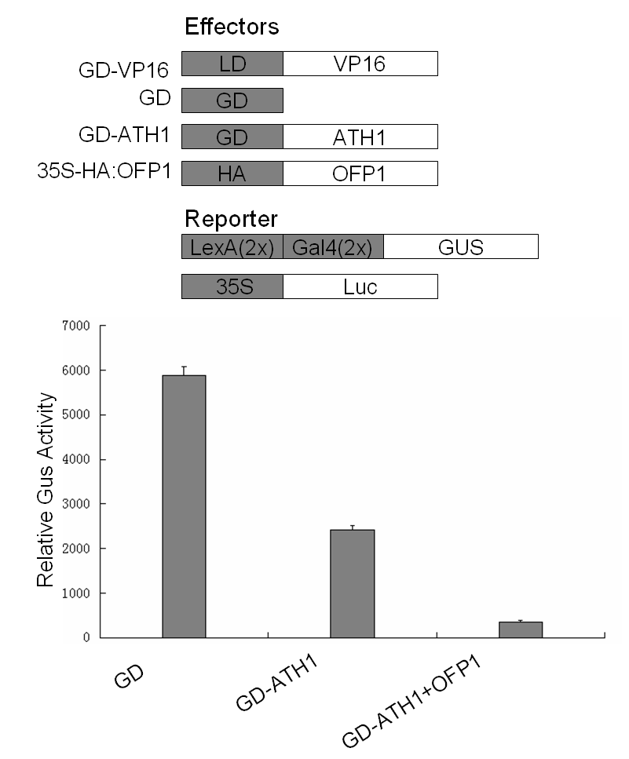
图1 ATH1是一个转录抑制因子, OFP1能够加强ATH1的转录抑制活性
Figure 1 ATH1 is a transcriptional repressor that interacts with OFP1 in vivo

1.2免疫共沉淀(Co-IP)确定ATH1和OFP1蛋白互作
免疫共沉淀研究结果显示，ATH1蛋白与OFP1蛋白之间体内互作关系。将提取的蛋白分成两个部分，一份是未经任何的处理的Input，另一份蛋白通过合成抗体或转化标签加入对应抗体，称之为IP。互作蛋白被FLAG抗体来检测，通过原生质体中共表达，来进行免疫共沉淀(Co-IP)分析，表明ATH1蛋白与OFP1蛋白在植物体内存在相互作用(图2)。
1.2 Co-IP determined the interaction between ATH1 and OFP1 proteins
The results of Co-IP showed that ATH1 protein and OFP1 protein interact in vivo. The extracted protein is divided into two parts, one is Input without any processing, and the other protein is added with corresponding antibody through synthetic antibody or transformation label, which is called IP. The interacting proteins were detected by FLAG antibodies and co-expressed in protoplasts for Co-IP analysis, indicating that ATH1 protein and OFP1 protein interacted in plants (Figure 2).
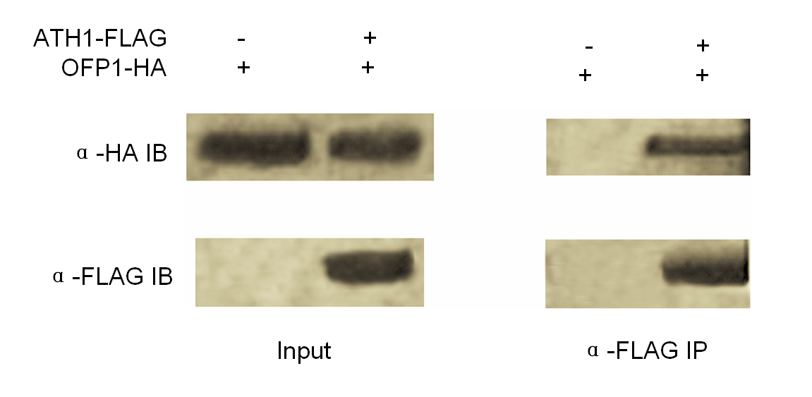
图2 OFP1-HA和ATH1-FALG免疫共沉淀试验结果
Figure 2 Co-expressing of ATH1- FALG and OFP1-HA

2讨论
与过去的研究相比(Hackbusch et al., 2005; Uddin et al., 2015)，本研究通过免疫共沉淀的方法确定了两个蛋白的体内互作关系，而不仅仅是通过高通量数据矩阵得出的一种肯能性。再者，采用拟南芥原生质体瞬时转染的方法确定ATH1是一个具有抑制作用的转录蛋白，进一步的体内蛋白互作试验表明在体内能够形成ATH1-OFP1蛋白复合物，但体内试验过程中也可能有其它蛋白因子的参与，因此，这种作用是间接的，就如同BELL-KNOX蛋白可能被OFP1负向调节一样，因此，转录蛋白复合物ATH1-OFP1的抑制作用可能被进一步的放大或缩减。
2 Discussion
Compared with previous studies (Hackbusch et al., 2005; Uddin et al., 2015), in this study, the in vivo interaction of two proteins was determined by Co-IP method, rather than just a feasibility obtained by high-throughput data matrix. Furthermore, ATH1 was identified as a transcription protein with inhibitory effect by transient transfection of Arabidopsis protoplasts. Further in vivo protein interaction experiments showed that ATH1-OFP1 protein complex could be formed in vivo, but other protein factors may also be involved in the in vivo experiment, so this effect is indirect. Just as the BELL-KNOX protein may be negatively regulated by OFP1. Therefore, the inhibition of ATH1-OFP1 by the transcriptional protein complex may be further amplified or reduced.

ATH1的蛋白序列中有一段序列LSLSLA，这是一段典型的转录抑制域结构，这段结构位于蛋白N端的SKY-BELL区域内。转染实验与免疫共沉淀实验表明，AtATH1能够与AtOFP1互作，且是一个转录抑制子，就LSLSLA结构来说，其抑制功能主要来源于3个L结构，其中前两个L起主要抑制功能，后一个为辅助抑制作用，最后一个L突变后抑制功能只会减弱不会消失。针对OFP1的研究表明，其与ATH1一样是一个转录抑制因子，但其既拥有OVATE结构域也拥有的3个L结构，由此结果暗示，蛋白因子OFP1负向调节靶基因的作用可能是多个因素共振的结果。
There is a sequence LSLSLA in the protein sequence of ATH1, which is a typical transcriptional inhibition domain structure located in the SKY-BELL region of the N-terminal of the protein. Transfection experiment and Co-IP experiments showed that AtATH1 could interact with AtOFP1, and was a transcriptional suppression. In terms of LSLSLA structure, its inhibition function mainly comes from 3 L structure, of which the first two L major inhibitory function, an auxiliary inhibitory effect, after the last one L mutation after inhibition function will weaken will not disappear. Studies on OFP1 showed that it was a transcription suppressor like ATH1, but it possessed both OVATE domain and three L structures. These results suggested that the negative regulation of OFP1 by target genes might be the result of resonance of multiple factors.

3材料与方法
3.1材料
本研究当中涉及的试验材料，均使用Columbia Arabidopsis (Col-0)类型拟南芥，包括基因转化类型以及突变体的材料。
3 Materials and Methods
3.1 Material
All the experimental materials involved in this study were Columbia Arabidopsis (Col-0) type, including the materials of gene transformation types and mutants.

3.2方法
3.2.1原生质体瞬时转染
拥有HA标签或者是GD标签的并同时带有2个35S启动子的PCR扩增物，与pUC19连接(McCarthy et al., 2009; Zhang et al., 2018)。为与HA标签对应，在被pZP211多元质粒转染前，应使用内切酶酶EcoRI酶切pUC19。
3.2 Methods
3.2.1 Transient transfection of protoplasts
PCR amplifiers with HA or GD tags and two 35S promoters linked to pUC19 (McCarthy et al., 2009; Zhang et al., 2018). To correspond to the HA label, pUC19 should be digested with endonuclease EcoRI enzyme before transfection by pZP211 plasmid.

为用作质粒提取实验和扩增实验，在pUC19载体中构建35S:GD-OFP1。在此转染活性实验中，Gal4(2X):GUS与LexA(2X)-Gal4(2X):GUS，反式作用因子LD-VP16，以及效应蛋白因子ATH1、OFP1均被使用到，见先前的报道(Zhang et al., 2016)。使用过去报道的方法开展原生质体的转染与提取实验(Zhang et al., 2016)，分析报告因子与效应质粒则使用试剂盒转染质粒系统(EndoFree Maxi kit -Plasmid)。Student's t test检验用作本试验的分析统计方法，且完成2次技术性与3次生物性重复实验。
35S: Gd-OFP1 was constructed into pUC19 vector for plasmid extraction and amplification experiments. In this transfection activity experiment, Gal4(2X):GUS and LexA(2X)-Gal4(2X):GUS, trans-acting factor LD-VP16, and effector protein factors ATH1 and OFP1 were used, as previously reported (Zhang et al., 2016). Protoplasts were transfected and extracted using the previously reported method (Zhang et al., 2016). Reporter factor and effector plasmid were analyzed, and EndoFree Maxi kit-Plasmid system was used. Student's T test was used as the statistical analysis method in this study, and two technical and three biological replicates were completed.

3.2.2免疫共沉淀(Co-IP)
为准确确定目标蛋白的表达量，拟南芥原生质体或者叶片的瞬时表达总蛋白被提取以用作Input。anti-flag M2 agarose (Sigma)取45 uL处理过的材料，原生质体总蛋白被加入其中，通过冰上低温孵育3 h，以便将非特异结合的蛋白剔除，从而竞争洗脱FLAG因子，与蛋白互作因子。同时，低温孵育1.5 3xFLAG多肽，其浓度为0.5 mg/mL。采用低温孵育1.5 h，之前需要将HA的抗体约2 μg加入其中，此后再处理1~2个小时，之前要加入proteinAagarose。然后完成至少3次清洗，使用该蛋白的缓冲液作为清洗液。在较高温度变异3 min前，需要在上清中加入1倍浓度的蛋白缓冲液体。
3.2.2 Co-IP
To accurately determine the expression level of the target protein, transient total proteins from Arabidopsis protoplasts or leaves were extracted for Input. anti-flag M2 agarose (Sigma) 45 μL treated material was taken, and total protoplasmic protein was added to the material, and incubated at low temperature on ice for 3 h to remove non-specific binding proteins, so as to competitively eluate flag factors and interact with protein factors. At the same time, 1.5 3xFLAG polypeptide was incubated at low temperature with the concentration of 0.5 mg/mL. After incubation at low temperature for 1.5 h, about 2 μg of HA antibody was added to it before treatment for 1~2 hours, and proteinAagarose was added before treatment. Then complete at least 3 washes, using the protein's buffer as a cleaning fluid. The protein buffer should be added to the supernatant with twice the concentration before 3 min variation at higher temperature.

作者贡献
张利国是本研究的实验设计和实验研究的执行人，完成了试验结果分析与论文写作；张效霏负责分析校对数据；常缨、王贵江与张树权给予了整体指导。全体作者都阅读并同意最终的文本。
Authors’ Contributions
ZLG is the experimental design and executor of this study, and has completed the analysis of the experimental results and the writing of the paper. ZXF is responsible for analyzing and proofreading data; CY, WGJ and ZSQ gave overall guidance. All authors read and approved the final manuscript.

致谢
本研究受黑龙江省自然科学基金(LH2020C097)、国家博士后基金(2018M630382)和黑龙江省农业科学院国自然培育项目(2019JJPY003)共同资助。
Acknowledgments
This study was supported by the Natural Science Foundation of Heilongjiang Province (LH2020C097), the National Postdoctoral Foundation of China (2018M630382), and the National Natural Cultivation Program of Heilongjiang Academy of Agricultural Sciences (2019JJPY003).

参考文献
References
Cole M., Nolte C., and Werr W., 2006, Nuclear import of the transcription factor SHOOT MERISTEMLESS depends on heterodimerization with BLH proteins expressed in discrete sub-domains of the shoot apical meristem of Arabidopsis thaliana, Nucleic Acids Research, 34(4): 1281-1292.
Gómez-Mena C., and Sablowski R., 2008, ARABIDOPSIS THALIANA HOMEOBOX GENE1 establishes the basal boundaries of shoot organs and controls stem growth, The Plant Cell, 20(8): 2059-2072.
Hackbusch J., Richter K., Müller J., Francesco S., and Joachim F.U., 2005, A central role of Arabidopsis thaliana ovate family proteins in networking and subcellular localization of 3-aa loop extension homeodomain proteins, Proceedings of the National Academy of Sciences of the United States of America, 102(13): 4908-4912.
Hake S., Smith H.M.S, Holtan H., Enrico M., Giovanni M., and Julio R., 2004, The role of knox genes in plant development, Annu. Rev. Cell Dev. Biol., 20(1): 125-151.
McCarthy R.L., Zhong R., and Ye Z.H., 2009, MYB83 is a direct target of SND1 and acts redundantly with MYB46 in the regulation of secondary cell wall biosynthesis in Arabidopsis, Plant Cell Physiol., 50(11): 1950-1964.
Uddin R., Saeed K., Khan W., Syed S.A., Abdul W., 2015, Metabolic pathway analysis approach: Identification of novel therapeutic target against methicillin resistant Staphylococcus aureus, Gene, 556(2): 213-226.
Zhang L.G., Sun L.L., Zhang X.F., Zhang S.Q., Xie D.W., Liang C.B., Huang W.G., Fan L.J., Fang Y.Y., and Chang Y., 2018, OFP1 Interaction with ATH1 Regulates Stem Growth, Flowering Time and Flower Basal Boundary Formation in Arabidopsis, Genes, 9(8): 399.
Zhang L.G., Zhang X.F., Ju H.X., Chen J.G., Wang S.C., Wang H.M., Zhao Y.L., and Chang Y., 2016, Ovate family protein1 interaction with BLH3 regulates transition timing from vegetative to reproductive phase in Arabidopsis, Biochemical & Biophysical Research Communications, 470(3): 492-497.

