Research Insight

**Advancing Carbon Sequestration and Emission Reduction in Agriculture: Strategies for Sustainable Rural Revitalization**

Yan Yan *

Pinghu Agricultural Ecological Energy Station, Pinghu, 314200, Zhejiang, China

* Corresponding author：[1749920615@qq.com](mailto:1749920615@qq.com)

**Abstract** This study explores the multifaceted strategies for enhancing carbon sequestration and reducing greenhouse gas emissions in agriculture, emphasizing their critical role in sustainable rural revitalization. By integrating climate-smart agricultural practices such as conservation tillage, cover cropping, and biochar application, as well as agroforestry systems, the research highlights methods to significantly improve soil organic carbon (SOC) sequestration. It further examines recommended management practices, including crop rotations and precision farming, which not only mitigate emissions but also enhance soil health. The study underscores the importance of stakeholder collaboration—farmers, policymakers, researchers, and the private sector—in driving these efforts. Advanced technologies like satellite monitoring and AI-based soil analysis are identified as crucial tools for optimizing carbon farming. Policy incentives, financial support, and interdisciplinary collaboration are recommended to foster the widespread adoption of sustainable practices. The findings contribute to the global drive for carbon neutrality, promoting a synergistic balance between environmental sustainability and rural community resilience.

**Keywords** Carbon sequestration; Sustainable agriculture; Climate-smart practices; Rural revitalization; Soil organic carbon

**1 Introduction**

The global push towards carbon neutrality has intensified in recent years, driven by the urgent need to mitigate climate change and its associated impacts. Agriculture, a significant contributor to greenhouse gas (GHG) emissions, plays a dual role in this context. On one hand, it is responsible for substantial carbon emissions through activities such as deforestation, soil cultivation, and livestock management (Lal, 2004; Sharma et al., 2021). On the other hand, agriculture holds immense potential for carbon sequestration, which involves capturing atmospheric carbon dioxide (CO2) and storing it in soil and biomass (Hutchinson et al., 2007; Bhattacharyya et al., 2021). This dual role positions agriculture as a critical sector in the global strategy to achieve carbon neutrality.

Sustainable rural revitalization is essential for achieving long-term environmental and economic goals. Rural areas, often heavily dependent on agriculture, face unique challenges such as soil degradation, loss of biodiversity, and economic instability. Implementing sustainable agricultural practices can address these challenges by enhancing soil health, increasing biodiversity, and providing economic benefits to rural communities (Aertsens et al., 2013; Sharma et al., 2021). Agroforestry, conservation tillage, and other sustainable practices not only improve carbon sequestration but also contribute to the overall resilience and sustainability of rural areas (Hutchinson et al., 2007; Lal, 2020). Thus, sustainable rural revitalization is not only a pathway to environmental sustainability but also a means to improve the livelihoods of rural populations.

This study focuses on advancing carbon sequestration and emission reduction strategies in agriculture, emphasizing their vital role in sustainable rural revitalization. It evaluates the effectiveness of practices such as agroforestry, conservation tillage, and cover cropping in enhancing carbon storage and reducing emissions, while also analyzing the socio-economic benefits of these measures for rural communities, including improved soil health, increased crop yields, and enhanced economic stability. Furthermore, the study identifies policy measures and incentives that promote the adoption of sustainable agricultural practices and integrates these strategies into broader rural development plans to ensure alignment between environmental and economic objectives. The aim is to contribute to global efforts toward carbon neutrality and sustainable development, highlighting the critical role of agriculture and rural communities in this process.

**2 Current Challenges in Agricultural Carbon Management**

**2.1 Economic constraints**

2.1.1 High input costs and low returns of green farming practices

Implementing green farming practices such as conservation tillage, cover cropping, and biochar applications often involves high initial costs and investments in new technologies and inputs. These practices, while beneficial for soil organic carbon (SOC) sequestration, can be economically burdensome for farmers, especially in the short term. For instance, biochar applications, although effective in increasing SOC content by 39%, require significant financial outlay (Bai et al., 2019). Additionally, the economic returns from these practices may not be immediately apparent, leading to reluctance among farmers to adopt them (Tiefenbacher et al., 2021).

2.1.2 Long gestation period for benefits from eco-friendly technologies

The benefits of eco-friendly technologies in agriculture, such as increased SOC levels and improved soil health, often take years to materialize. This long gestation period can be a significant deterrent for farmers who need more immediate returns on their investments. For example, the new equilibrium SOC level may be achieved over 25 to 50 years, making it challenging for farmers to see the immediate benefits of their efforts (Jarecki and Lal, 2003). This delay in realizing benefits can hinder the widespread adoption of sustainable practices.

2.1.3 Limited recognition of eco-labeled products in the market

Eco-labeled products, which are produced using sustainable farming practices, often struggle to gain recognition and command premium prices in the market. This limited market recognition can reduce the financial incentives for farmers to adopt green practices. Despite the environmental benefits, such as reduced greenhouse gas emissions and improved soil health, the lack of consumer awareness and demand for eco-labeled products can undermine the economic viability of sustainable agriculture (Saikanth et al., 2023).

**2.2 Spatial and structural limitations**

2.2.1 Shortage of buffer zones and treatment facilities

The implementation of effective carbon management practices in agriculture is often hampered by the shortage of buffer zones and treatment facilities. These spatial limitations can restrict the ability to manage and treat agricultural runoff, which is crucial for maintaining soil health and enhancing carbon sequestration. For instance, the lack of adequate buffer zones can lead to increased soil erosion and nutrient runoff, negatively impacting SOC levels (Govaerts et al., 2009).

2.2.2 Spatial planning conflicts with carbon management goals

Conflicts between spatial planning and carbon management goals can arise when land use priorities do not align with the objectives of carbon sequestration. For example, the conversion of agricultural land to urban or industrial use can reduce the available area for implementing carbon farming practices, thereby limiting the potential for SOC sequestration (Kåresdotter et al., 2022). Effective spatial planning that integrates carbon management goals is essential for maximizing the benefits of sustainable agriculture.

2.2.3 Disconnection in the agricultural circular economy

A well-functioning agricultural circular economy is crucial for effective carbon management. However, disconnections in this system, such as the lack of integration between crop and livestock production or the inefficient use of agricultural residues, can hinder carbon sequestration efforts. For instance, incorporating crop residues into the soil is a promising practice for increasing SOC content, but it requires a coordinated approach that is often lacking in fragmented agricultural systems (Qiu et al., 2009).

**2.3 Gaps in measurement and standardization**

2.3.1 Lack of unified carbon accounting standards

The absence of unified carbon accounting standards poses a significant challenge for measuring and verifying the carbon sequestration potential of different agricultural practices. This lack of standardization can lead to inconsistencies in data and make it difficult to compare the effectiveness of various practices. For example, the wide divergence in measurements regarding the influences of climate-smart agriculture (CSA) practices on SOC sequestration highlights the need for standardized accounting methods (Bai et al., 2019).

2.3.2 Inadequate frameworks for low-carbon agriculture

Current frameworks for promoting low-carbon agriculture are often inadequate, lacking the necessary guidelines and support for farmers to implement sustainable practices effectively. This inadequacy can result in suboptimal adoption rates and reduced impact on carbon sequestration. For instance, while conservation agriculture has been shown to improve soil health and reduce emissions, the lack of comprehensive frameworks to support its implementation limits its widespread adoption (Francaviglia et al., 2023) (Figure 1).

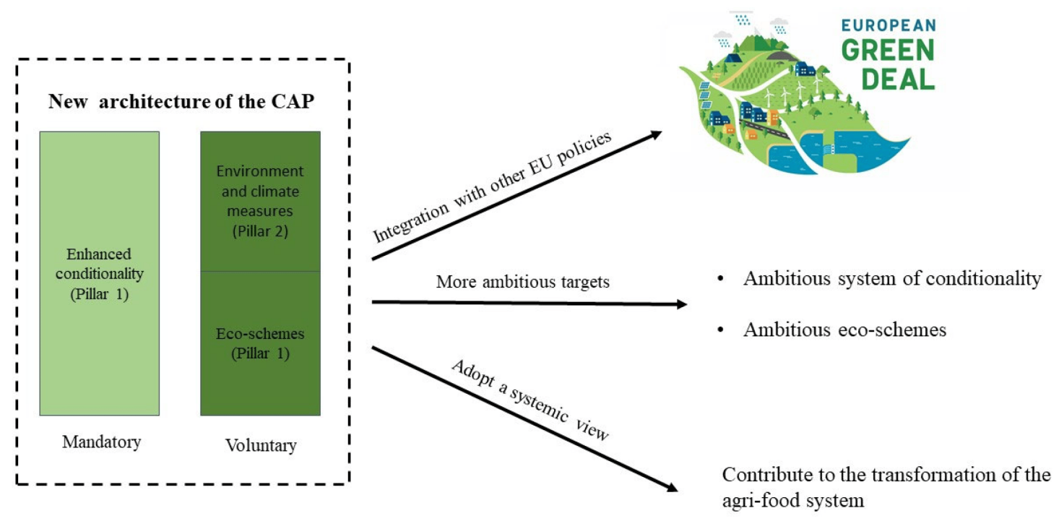

Figure 1 The three challenges related to the new architecture of the European Common Agricultural Policy (CAP) (Adopted from Francaviglia et al., 2023)

2.3.3 Absence of robust feedback mechanisms for environment-agriculture interactions

Robust feedback mechanisms that monitor and evaluate the interactions between agricultural practices and environmental outcomes are essential for adaptive management. However, the absence of such mechanisms can hinder the ability to make informed decisions and optimize carbon management strategies. For example, the lack of feedback on the impacts of different carbon farming practices on nitrogen cycling and greenhouse gas emissions can lead to unintended consequences, such as increased nitrous oxide emissions (Almaraz et al., 2021).

**3 Strategies for Optimizing Agricultural Systems**

**3.1 Structural adjustments**

Balancing crop and livestock systems is essential for enhancing productivity and sustainability in agricultural practices. Integrating livestock with crop production can improve soil organic carbon (SOC) levels, which is crucial for soil health and fertility. For instance, agroforestry systems that combine trees, crops, and livestock have shown significant potential in increasing carbon sequestration and reducing greenhouse gas (GHG) emissions (Bhattacharyya et al., 2021; Sharma et al., 2021). Additionally, practices such as using cover crops and crop residue management can further enhance SOC levels and improve overall soil quality (Jarecki and Lal, 2003; Bai et al., 2019). These integrated systems not only boost productivity but also contribute to climate change mitigation by sequestering carbon in both plant biomass and soil (Shrestha et al., 2018; Sharma et al., 2021).

Implementing long-term land leasing policies can encourage green investments in sustainable agricultural practices. Such policies provide farmers with the security needed to invest in long-term soil health and carbon sequestration strategies. For example, the adoption of conservation tillage, cover crops, and biochar applications has been shown to significantly enhance SOC sequestration (Bai et al., 2019; Tiefenbacher et al., 2021). These practices require sustained efforts and investments, which are more feasible under long-term land tenure arrangements. Moreover, policies that support the conversion of marginal lands into restorative uses, such as agroforestry, can further enhance carbon sequestration and improve ecosystem services (Lal, 2004; Bhattacharyya et al., 2021).

**3.2 Branding and market systems**

Promoting eco-labeled products and carbon-tagged certifications can drive consumer demand for sustainably produced agricultural goods. Eco-labels and carbon certifications provide transparency about the environmental impact of products, encouraging consumers to make more sustainable choices. For instance, products from agroforestry systems, which integrate trees with crops and livestock, can be marketed as carbon-neutral or even carbon-negative, given their high potential for carbon sequestration (Jarecki and Lal, 2003; Sharma et al., 2021). Such certifications can also incentivize farmers to adopt practices that enhance SOC and reduce GHG emissions, thereby contributing to climate change mitigation (Shrestha et al., 2018; Bhattacharyya et al., 2021).

Strengthening supply chains for sustainable agricultural products is crucial for ensuring that eco-labeled and carbon-tagged products reach the market effectively. This involves improving the logistics, storage, and distribution networks to handle sustainably produced goods. For example, enhancing the supply chain for products from conservation tillage and cover crop systems can ensure that these goods maintain their eco-friendly attributes from farm to table (Bai et al., 2019; Tiefenbacher et al., 2021). Additionally, creating robust supply chains for agroforestry products can help in scaling up these sustainable practices, thereby increasing their impact on carbon sequestration and GHG emission reduction (Jarecki and Lal, 2003; Sharma et al., 2021).

**4 Enhancing Carbon Sequestration Potential**

**4.1 Soil carbon storage**

The application of organic fertilizers, such as compost and manure, plays a significant role in enhancing soil organic carbon (SOC) storage. Organic fertilizers increase carbon inputs to the soil, which can sequester up to (714±404) kg C ha-1 y-1 (Tiefenbacher et al., 2021). The use of biochar, a form of organic amendment, has been shown to increase SOC content by 39% on average, making it one of the most effective methods for SOC enhancement (Bai et al., 2019). Additionally, organic amendments like compost emit less CO2 and N2O compared to raw manure, making them more environmentally friendly options (Shrestha et al., 2018).

Conservation tillage practices, including no-tillage and reduced tillage, are effective in reducing soil erosion and maintaining soil structure, which in turn helps in SOC sequestration. These practices have been found to increase SOC by 5% on average (Bai et al., 2019). However, the impact of no-tillage is often limited to the topsoil (0~10 cm), and its overall effectiveness can vary based on local environmental conditions (Bhattacharyya et al., 2021). Despite these limitations, conservation tillage remains a viable strategy for enhancing soil carbon storage (Jarecki and Lal, 2003).

Crop rotation practices, including the use of cover crops and ley farming, contribute to SOC sequestration by increasing the diversity of organic matter inputs to the soil. These practices help in maintaining soil fertility and structure, which are crucial for long-term carbon storage (Jarecki and Lal, 2003). Cover crops alone have been shown to increase SOC content by 6% (Bai et al., 2019). Additionally, incorporating forages and reducing bare fallow periods can further enhance SOC levels (Hutchinson et al., 2007).

**4.2 Ecosystem services**

Agroforestry systems, which integrate trees with crops and/or livestock, are highly effective in sequestering carbon both above and below ground. These systems can sequester between 0.09 and 7.29 t C ha-1 a-1, depending on the specific practices implemented (Kay et al., 2019). Agroforestry not only enhances carbon sequestration but also provides additional ecosystem services such as biodiversity enhancement and soil erosion control (Nair et al., 2009; Sharma et al., 2021). The integration of trees in agricultural landscapes can significantly contribute to carbon sequestration and environmental sustainability (Bhattacharyya et al., 2021).

Cover cropping involves planting crops that cover the soil surface, thereby reducing soil erosion and increasing organic matter inputs. This practice has been shown to increase SOC content by 6% on average (Bai et al., 2019). Cover crops also improve soil health by enhancing nutrient cycling and water retention, which are essential for long-term carbon storage (Jarecki and Lal, 2003). The use of grasses and cereals as cover crops has been particularly effective in sequestering carbon in soils (Bhattacharyya et al., 2021).

**4.3 Carbon sequestration technologies**

Innovations in soil carbon monitoring technologies are crucial for accurately assessing SOC levels and the effectiveness of various carbon sequestration practices. Advanced soil sensors and remote sensing technologies enable precise measurement of SOC changes over time, providing valuable data for optimizing carbon sequestration strategies (Hutchinson et al., 2007). These technologies help in identifying the most effective practices for different soil types and climatic conditions, thereby enhancing the overall carbon sequestration potential (Lal, 2004).

Data analysis techniques, including machine learning and statistical modeling, are essential for understanding the complex interactions between soil management practices and SOC sequestration. These techniques allow for the integration of large datasets from various sources, enabling more accurate predictions of SOC changes and the identification of best management practices (Hutchinson et al., 2007). By leveraging data analysis, researchers can develop more effective strategies for enhancing carbon storage in agricultural soils (Lal, 2004).

**5 Integrating Renewable Energy in Agriculture**

**5.1 Energy transition in farming practices**

Biogas energy, derived from the anaerobic digestion (AD) of organic waste, is a promising renewable energy source for agriculture. AD processes convert agricultural residues, livestock waste, and other organic materials into biogas, which can be used for heat and power generation (Figure 2). This not only reduces greenhouse gas emissions but also provides a sustainable energy source for farms (Purdy et al., 2018; Tamburini et al., 2020; Xu et al., 2021). The Biogasdoneright™ system, for instance, integrates biogas production with sustainable agricultural practices, enhancing both energy recovery and carbon sequestration (Dale et al., 2020; Magnolo et al., 2021).

Solar energy integration in agriculture involves the use of photovoltaic panels to harness solar power for various farming operations. This renewable energy source can be used to power irrigation systems, greenhouses, and other farm equipment, reducing reliance on fossil fuels and lowering carbon footprints. Solar energy systems are particularly beneficial in regions with high solar irradiance, providing a reliable and sustainable energy source for agricultural activities (O'Keeffe and Thrän, 2019; Sharma et al., 2021).

Wind energy applications in agriculture include the use of wind turbines to generate electricity for farm operations. Wind power is a clean and renewable energy source that can significantly reduce greenhouse gas emissions. Farms located in windy regions can benefit from installing wind turbines to meet their energy needs, contributing to a more sustainable and energy-efficient agricultural system (O'Keeffe and Thrän, 2019; Sharma et al., 2021).

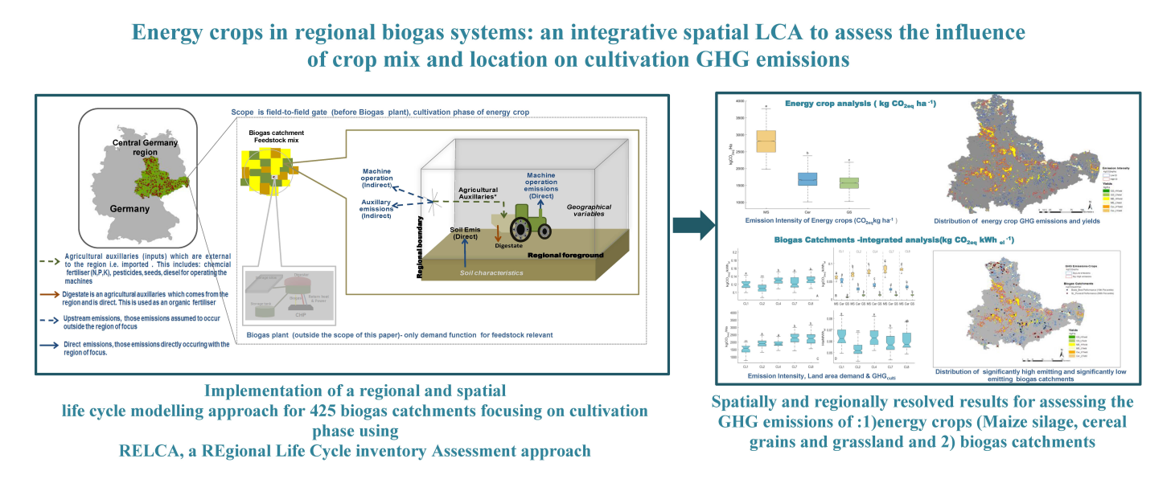

Figure 2 Regional LCA of energy crops impacting crop mix and location on GHG emissions (Adapted from O'Keeffe and Thrän, 2019)

**5.2 Waste-to-energy systems**

Biomass energy from agricultural residues involves converting crop residues, animal manure, and other organic waste into bioenergy through processes like anaerobic digestion and combustion. This approach not only provides a renewable energy source but also helps manage agricultural waste, reducing environmental pollution and enhancing soil health through the application of digestate as a fertilizer (Atelge et al., 2020; Tamburini et al., 2020; Xu et al., 2021).

Circular energy utilization in agriculture focuses on creating closed-loop systems where waste products are recycled and reused within the farming ecosystem. For example, the digestate from anaerobic digestion can be used as a nutrient-rich fertilizer, closing the nutrient loop and reducing the need for synthetic fertilizers. This approach promotes sustainability by minimizing waste and maximizing resource efficiency (Atelge et al., 2020; Tamburini et al., 2020; Xu et al., 2021).

**5.3 Case studies**

Several case studies highlight the successful integration of renewable energy in agriculture. For instance, the Emilia Romagna region in Italy has effectively utilized biogas production from agricultural and agri-food waste, resulting in significant greenhouse gas emission reductions and energy savings (Tamburini et al., 2020). Another example is the Biogasdoneright™ system in Italy, which combines sequential cropping with biogas production to enhance sustainability and energy efficiency in agricultural systems (Dale et al., 2020; Magnolo et al., 2021). These case studies demonstrate the potential of renewable energy integration to transform agricultural practices, making them more sustainable and resilient to climate change.

**6 Policy Recommendations for Carbon-Positive Agriculture**

**6.1 Incentives for green farming practices**

To promote carbon-positive agriculture, it is essential to provide incentives for adopting green farming practices. Financial incentives such as subsidies, carbon credits, and tax breaks can motivate farmers to implement sustainable practices like conservation tillage, cover cropping, and agroforestry. For instance, subsidies have been shown to increase farmers' efforts to build soil organic carbon (SOC) (Hermann et al., 2017). Additionally, agroforestry systems, which integrate trees with crops and livestock, have been identified as highly effective in sequestering carbon and improving soil health (Bhattacharyya et al., 2021; Sharma et al., 2021). By offering economic benefits, these incentives can encourage widespread adoption of practices that enhance carbon sequestration and reduce greenhouse gas emissions.

**6.2 Development of national and regional carbon accounting frameworks**

Establishing robust carbon accounting frameworks at national and regional levels is crucial for accurately measuring and managing carbon sequestration in agriculture. These frameworks should include standardized methods for quantifying SOC changes and greenhouse gas emissions from various agricultural practices. Accurate carbon accounting can help in assessing the effectiveness of different practices and policies, thereby guiding future actions. For example, the adoption of recommended management practices (RMPs) such as crop rotations, cover crops, and reduced tillage has been shown to significantly enhance SOC levels (Jarecki and Lal, 2003). Implementing comprehensive carbon accounting systems will ensure that these practices are properly monitored and rewarded, thereby promoting their adoption.

**6.3 Interdisciplinary and international collaboration opportunities**

Interdisciplinary and international collaborations are vital for advancing carbon-positive agriculture. Collaborative efforts can facilitate the exchange of knowledge, technologies, and best practices across different regions and disciplines. For instance, integrating insights from soil science, agronomy, economics, and policy studies can lead to more effective strategies for carbon sequestration (Lal, 2004; Hutchinson et al., 2007). International collaborations can also help in addressing region-specific challenges and opportunities, such as the unique potential of agroforestry in tropical regions (Hutchinson et al., 2007). By fostering partnerships among researchers, policymakers, and practitioners globally, we can accelerate the development and implementation of innovative solutions for sustainable agriculture.

**7 Case Studies and Regional Insights**

**7.1 In-depth analysis of successful carbon management projects**

Successful carbon management projects in agriculture have demonstrated significant potential in enhancing soil organic carbon (SOC) sequestration and reducing greenhouse gas emissions. For instance, a meta-analysis of climate-smart agriculture (CSA) practices, including conservation tillage, cover crops, and biochar applications, revealed that biochar applications were the most effective, increasing SOC content by 39%, followed by cover crops (6%) and conservation tillage (5%) (Bai et al., 2019). These practices were particularly effective in warmer climates or areas with lower nitrogen fertilizer inputs, highlighting the importance of local environmental factors in the success of carbon management projects.

In another case, the 4p1000 initiative, which aims to increase SOC storage through sustainable practices, has shown promise in addressing climate change adaptation, mitigation, and food security simultaneously. This initiative emphasizes the need for region-specific practices and collaboration among policymakers, practitioners, scientists, and stakeholders to stimulate innovation and transition agricultural systems toward sustainability (Rumpel et al., 2019). Despite some criticism regarding its numerical targets, the initiative has provided a collaborative platform for developing and implementing effective carbon management strategies.

**7.2 Region-specific challenges and tailored solutions**

Different regions face unique challenges in implementing carbon sequestration practices, necessitating tailored solutions. For example, in Australia, the government's Emission Reduction Fund (ERF) encourages farmers to adopt practices that increase soil carbon stocks and earn Australian Carbon Credit Units (ACCUs). However, the success of this program is hindered by biophysical constraints such as variable rainfall and the high costs of compliance and practice changes (White, 2022). To address these challenges, it is crucial to develop region-specific strategies that consider local environmental conditions and economic factors.

In Northern Italy, the influence of agronomic practices on soil carbon sequestration varies significantly across different pedoclimatic settings. For instance, organic farms in the Northern Apennines, characterized by minimal soil disturbance and cold climates, showed higher SOC sequestration compared to conventional farms on the Po Plain, where warmer climates and moderately alkaline environments enhanced soil microbial activity, leading to lower SOC levels (Brombin et al., 2020) (Figure 3; Table 1). This underscores the need for thorough soil investigations and tailored best practices that reconcile productivity with soil sustainability.

In China, the spatial-temporal dynamics of carbon footprints in crop production revealed that practices such as straw return and improved fertilization efficiency significantly mitigated greenhouse gas emissions. However, the primary drivers of emissions varied across regions, with fertilization, machinery operation, and rice paddy methane flux being the main contributors in different areas (Liu et al., 2018). This highlights the importance of implementing region-specific management practices to effectively reduce emissions and enhance carbon sequestration.

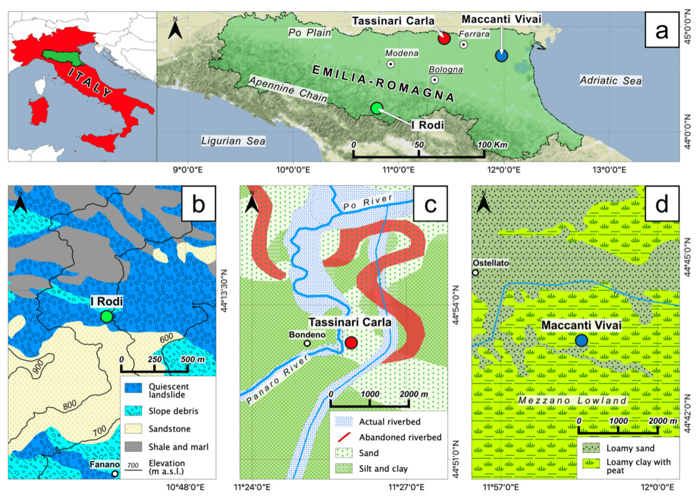

Figure 3 (a) Locations of the investigated farms within the Emilia-Romagna region (Northern Italy). Simplified geomorphological maps of the studied areas showing the location of (b) the I Rodi (IR) farm in the Apennines, as well as the (c) Tassinari Carla (BT) farm and (d) Maccanti Vivai (MV) farm on the Po Plain (Adopted from Brombin et al., 2020)

Table 1 Average organic carbon stock in soil collected at 0-30 cm in the different fields of the I Rodi (IR) farm, Tassinari Carla (BT) farm, and Maccanti Vivai (MV) farm. The respective bulk densities for each investigated area are also reported (Adopted from Brombin et al., 2020)

|  |  |  |
| --- | --- | --- |
| Field | Bulk Density (g/cm3) | OC Stock (Mg/ha) |
| IR farm | 1.24 |  |
| Grassland |  | 85.9 |
| Low-yield |  | 84.1 |
| Productive |  | 159.6 |
| BT farm | 1.40 |  |
| Turfed orchard (since 1992) |  | 40.3 |
| Vegetable garden (since 1992) |  | 48.3 |
| Turfed orchard (since 2007) |  | 43.7 |
| Vegetable garden (since 2007) |  | 41.4 |
| Vegetable garden (since 1996) |  | 40.4 |
| Harrowed | 1.13 | 33.0 |
| Strawberry (since 1996) |  | 37.4 |
| MV farm |  |  |
| 1-year-old pear orchard nursery |  | 267.3 |
| 2-year-old pear orchard nursery |  | 248.0 |
| 3-year-old pear orchard nursery |  | 228.6 |

**8 Future Perspectives in Low-Carbon Agriculture**

**8.1 Technological innovations**

Precision agriculture technologies are pivotal in optimizing resource use and enhancing carbon sequestration in agricultural systems. By employing tools such as remote sensing, GPS, and data analytics, precision agriculture can tailor inputs like water, fertilizers, and pesticides to the specific needs of crops, thereby reducing waste and emissions. For instance, simulation models have demonstrated that precision agriculture can significantly reduce soil organic carbon (SOC) losses and greenhouse gas (GHG) emissions by optimizing tillage practices and input management (Cillis et al., 2018). Additionally, precision agriculture can help in monitoring and managing soil health, which is crucial for maintaining high levels of SOC and ensuring sustainable crop production (Bai et al., 2019; Tiefenbacher et al., 2021).

Smart farming technologies, including the use of sensors, drones, and autonomous machinery, offer innovative solutions for reducing the carbon footprint of agriculture. These technologies enable real-time monitoring and management of farm operations, leading to more efficient use of resources and lower emissions. For example, the integration of conservation tillage with precision agriculture technologies has been shown to reduce carbon emissions by up to 56% compared to conventional tillage practices (Cillis et al., 2018). Moreover, advancements in digital agriculture and crop genetics have the potential to significantly reduce GHG emissions from row-crop farming, although widespread adoption remains a challenge due to economic and infrastructural barriers (Amundson, 2022).

**8.2 Education and capacity building**

Effective training programs are essential for equipping farmers with the knowledge and skills needed to adopt low-carbon agricultural practices. These programs should focus on the benefits and implementation of practices such as conservation tillage, cover cropping, and biochar application, which have been shown to enhance SOC sequestration and reduce GHG emissions (Bai et al., 2019; Bhattacharyya et al., 2021). Additionally, training should include the use of precision agriculture and smart farming technologies to optimize resource use and minimize environmental impact (Cillis et al., 2018). By providing hands-on training and continuous support, farmers can be empowered to make informed decisions that contribute to sustainable agriculture and climate change mitigation (Saikanth et al., 2023).

Knowledge dissemination is crucial for the widespread adoption of sustainable agricultural practices. This can be achieved through various channels, including extension services, farmer field schools, and digital platforms. Sharing success stories and best practices can motivate farmers to adopt new techniques and technologies that enhance carbon sequestration and reduce emissions (Lal, 2020). Furthermore, collaboration between researchers, policymakers, and farmers is necessary to ensure that the latest scientific findings and technological advancements are effectively communicated and implemented at the farm level (Kaur et al., 2023; Rosa and Gabrielli, 2023).

**8.3 Global implications**

Low-carbon agriculture has significant implications for global food security. By improving soil health and fertility through practices such as agroforestry, cover cropping, and reduced tillage, agricultural systems can become more resilient to climate change and more productive (Sharma et al., 2021; Saikanth et al., 2023). Enhanced SOC levels not only sequester carbon but also improve water retention and nutrient availability, leading to higher crop yields and more stable food supplies (Kaur et al., 2023). This is particularly important for developing countries, where sustainable agricultural practices can play a critical role in ensuring food security and supporting rural livelihoods (Bhattacharyya et al., 2021).

Adopting low-carbon agricultural practices aligns with global climate goals, such as those outlined in the Paris Agreement. Practices that enhance carbon sequestration and reduce GHG emissions contribute to the overall reduction of atmospheric CO2 levels, helping to mitigate climate change (Lal, 2020; Tiefenbacher et al., 2021). For instance, the "4 per 1000" initiative aims to increase global SOC stocks by 0.4% per year, which could significantly offset global GHG emissions if widely adopted (Lal, 2020). By integrating these practices into national and international climate strategies, agriculture can transition from being a major emitter to a key player in climate change mitigation (Amundson, 2022; Rosa and Gabrielli, 2023).

**9 Conclusion**

Advancing carbon sequestration and reducing emissions in agriculture requires a multifaceted approach that integrates innovative practices with supportive policies. Key strategies include the adoption of climate-smart agricultural (CSA) practices such as conservation tillage, cover cropping, and biochar application. These methods have proven effective in enhancing soil organic carbon (SOC) sequestration and minimizing greenhouse gas emissions. Agroforestry, which combines trees with crops and livestock, is particularly noteworthy as it significantly boosts carbon storage both above and below ground.

Furthermore, implementing recommended management practices (RMPs) such as crop rotations, the application of manure and biosolids, and precision farming can further enhance SOC levels while improving overall soil health. Policies that incentivize these methods, including carbon credits and financial subsidies, are vital to driving adoption among farmers. The potential of agricultural soils for carbon sequestration is substantial, with these practices estimated to offset a significant proportion of annual CO2 emissions.

Achieving sustainable rural revitalization through carbon sequestration and emission reduction demands collaboration among farmers, policymakers, researchers, and the private sector. Farmers, as the key implementers of carbon sequestration practices, play a central role, and their active participation is essential. Governments must support these efforts by establishing policies that provide financial incentives and technical assistance to farmers.

Research institutions and universities can contribute by conducting studies to refine and validate carbon sequestration techniques, ensuring their effectiveness across diverse environmental conditions. Meanwhile, the private sector, including agribusinesses and technology firms, can support these initiatives by developing innovative tools and promoting practices that enhance carbon sequestration and lower emissions.

Collaboration among these stakeholders can create a synergistic impact, leading to more effective and sustainable outcomes. Integrating advanced technologies such as satellite monitoring and AI-driven soil analysis can optimize carbon farming practices and monitor their effects on SOC sequestration and soil health. By working together, stakeholders can ensure that carbon sequestration strategies not only combat climate change but also enhance the sustainability and resilience of rural communities.

**Acknowledgments**

I deeply appreciate the reviewers for their insightful comments and revision suggestions during the review process. These inputs have not only elevated the academic quality of the paper but also provided new perspectives for my future research.

**Conflict of Interest Disclosure**

The authors affirm that this research was conducted without any commercial or financial relationships that could be construed as a potential conflict of interest.

**References**

Aertsens J., Nocker L., and Gobin A., 2013, Valuing the carbon sequestration potential for European agriculture, Land Use Policy, 31:584-594. <https://doi.org/10.1016/J.LANDUSEPOL.2012.09.003.>

Almaraz M., Wong M., Geoghegan E., and Houlton B., 2021, A review of carbon farming impacts on nitrogen cycling, retention, and loss., Annals of the New York Academy of Sciences, 1505. <https://doi.org/10.1111/nyas.14690.>

Amundson R., 2022, Negative emissions in agriculture are improbable in the near future. Proceedings of the National Academy of Sciences of the United States of America, 119. <https://doi.org/10.1073/pnas.2118142119.>

Atelge M., Atelge M., Krisa D., Kumar G., Eskicioglu C., Nguyen D., Chang S., Atabani A., Al-Muhtaseb A., and Ünalan S., 2020, Biogas Production from Organic Waste: Recent Progress and Perspectives, Waste and Biomass Valorization, 11: 1019-1040. <https://doi.org/10.1007/S12649-018-00546-0.>

Bai X., Huang Y., Ren W., Coyne M., Jacinthe P., Tao B., Hui D., Yang J., and Matocha C., 2019, Responses of soil carbon sequestration to climate‐smart agriculture practices: A meta-analysis, Global Change Biology, 25: 2591-2606. <https://doi.org/10.1111/gcb.14658.>

Bhattacharyya S., Leite F., Adeyemi M., Sarker A., Cambareri G., Faverín C., Tieri M., Castillo-Zacarías C., Melchor-Martínez E., Iqbal H., and Parra-Saldívar R., 2021, A paradigm shift to CO2 sequestration to manage global warming - With the emphasis on developing countries, The Science of the total environment, 790: 148169. <https://doi.org/10.1016/J.SCITOTENV.2021.148169.>

Brombin V., Mistri E., Feudis M., Forti C., Salani G., Natali C., Falsone G., Antisari L., and Bianchini G., 2020, Soil Carbon Investigation in Three Pedoclimatic and Agronomic Settings of Northern Italy, Sustainability. <https://doi.org/10.3390/su122410539.>

Cillis D., Maestrini B., Pezzuolo A., Marinello F., and Sartori L., 2018, Modeling soil organic carbon and carbon dioxide emissions in different tillage systems supported by precision agriculture technologies under current climatic conditions, Soil and Tillage Research. <https://doi.org/10.1016/J.STILL.2018.06.001.>

Dale B., Bozzetto S., Couturier C., Fabbri C., Hilbert J., Ong R., Richard T., Rossi L., Thelen K., and Woods J., 2020, The potential for expanding sustainable biogas production and some possible impacts in specific countries, Biofuels, 14. <https://doi.org/10.1002/bbb.2134.>

Francaviglia R., Almagro M., and Vicente-Vicente J., 2023, Conservation Agriculture and Soil Organic Carbon: Principles, Processes, Practices and Policy Options. Soil Systems. <https://doi.org/10.3390/soilsystems7010017.>

Govaerts B., Verhulst N., Castellanos-Navarrete A., Sayre K., Dixon J., and Dendooven L., 2009. Conservation Agriculture and Soil Carbon Sequestration: Between Myth and Farmer Reality, Critical Reviews in Plant Sciences, 28: 122-197. <https://doi.org/10.1080/07352680902776358.>

Hermann D., Sauthoff S., and Musshoff O., 2017, Ex-ante evaluation of policy measures to enhance carbon sequestration in agricultural soils, Ecological Economics, 140: 241-250. <https://doi.org/10.1016/J.ECOLECON.2017.05.018.>

Hutchinson J., Campbell C., and Desjardins R., 2007, Some perspectives on carbon sequestration in agriculture, Agricultural and Forest Meteorology, 142: 288-302. <https://doi.org/10.1016/J.AGRFORMET.2006.03.030.>

Jarecki M., and Lal R., 2003, Crop Management for Soil Carbon Sequestration, Critical Reviews in Plant Sciences, 22: 471-502. <https://doi.org/10.1080/713608318.>

Kåresdotter E., Bergqvist L., Flores-Carmenate G., Haller H., and Jonsson A., 2022, Modeling the Carbon Sequestration Potential of Multifunctional Agroforestry-Based Phytoremediation (MAP) Systems in Chinandega, Nicaragua. Sustainability. <https://doi.org/10.3390/su14094932.>

Kaur R., Kaur N., Kumar S., Dass A., and Singh T., 2023, Carbon capture and sequestration for sustainable land use – A review, The Indian Journal of Agricultural Sciences. <https://doi.org/10.56093/ijas.v93i1.124838.>

Kay S., Rega C., Moreno G., Herder M., Palma J., Borek R., Crous-Duran J., Freese D., Giannitsopoulos M., Graves A., Jäger M., Lamersdorf N., Memedemin D., Mosquera-Losada R., Pantera A., Paracchini M., Paris P., Roces-Díaz J., Rolo V., Rosati A., Șandor M., Smith J., Szerencsits E., Varga A., Viaud V., Wawer R., Burgess P., and Herzog F., 2019, Agroforestry creates carbon sinks whilst enhancing the environment in agricultural landscapes in Europe. Land Use Policy. <https://doi.org/10.1016/J.LANDUSEPOL.2019.02.025.>

Lal R., 2004, Soil carbon sequestration to mitigate climate change. Geoderma, 123: 1-22. <https://doi.org/10.1016/J.GEODERMA.2004.01.032.>

Lal R., 2020. The role of industry and the private sector in promoting the “4 per 1000” initiative and other negative emission technologies, Geoderma, 378: 114613. <https://doi.org/10.1016/j.geoderma.2020.114613.>

Liu W., Zhang G., Wang X., Lu F., and Ouyang Z., 2018, Carbon footprint of main crop production in China: Magnitude, spatial-temporal pattern and attribution.. The Science of the total environment, 645: 1296-1308. <https://doi.org/10.1016/j.scitotenv.2018.07.104.>

Magnolo F., Dekker H., Decorte M., Bezzi G., Rossi L., Meers E., and Speelman S., 2021, The Role of Sequential Cropping and Biogasdoneright™ in Enhancing the Sustainability of Agricultural Systems in Europe. Agronomy. <https://doi.org/10.3390/agronomy11112102.>

Nair P., Kumar B., Kumar B., and Nair V., 2009, Agroforestry as a strategy for carbon sequestration. Journal of Plant Nutrition and Soil Science, 172: 10-23. <https://doi.org/10.1002/JPLN.200800030.>

O'Keeffe S., and Thrän D., 2019. Energy Crops in Regional Biogas Systems: An Integrative Spatial LCA to Assess the Influence of Crop Mix and Location on Cultivation GHG Emissions, Sustainability. <https://doi.org/10.3390/su12010237.>

Purdy A., Pathare P., Wang Y., Roskilly A., and Huang Y., 2018, Towards sustainable farming: Feasibility study into energy recovery from bio-wastes on a small-scale dairy farm, Journal of Cleaner Production, 174: 899-904. <https://doi.org/10.1016/J.JCLEPRO.2017.11.018.>

Qiu J., Li C., Wang L., Tang H., Li H., and Ranst E., 2009, Modeling impacts of carbon sequestration on net greenhouse gas emissions from agricultural soils in China. Global Biogeochemical Cycles, 23. <https://doi.org/10.1029/2008GB003180.>

Rosa L., and Gabrielli P., 2023, Achieving net-zero emissions in agriculture: a review. Environmental Research Letters, 18. <https://doi.org/10.1088/1748-9326/acd5e8.>

Rumpel C., Amiraslani F., Chenu C., Cardenas M., Kaonga M., Koutika L., Ladha J., Madari B., Shirato Y., Smith P., Soudi B., Soussana J., Whitehead D., and Wollenberg E., 2019, The 4p1000 initiative: Opportunities, limitations and challenges for implementing soil organic carbon sequestration as a sustainable development strategy. Ambio, 49: 350-360. <https://doi.org/10.1007/s13280-019-01165-2.>

Saikanth D., Kishore A., Sadineni T., Singh V., Upadhyay L., Kumar S., and Panigrahi C., 2023, A Review on Exploring Carbon Farming as a Strategy to Mitigate Greenhouse Gas Emissions. International Journal of Plant and Soil Science. <https://doi.org/10.9734/ijpss/2023/v35i234253.>

Sharma M., Kaushal R., Kaushik P., and Ramakrishna S., 2021, Carbon Farming: Prospects and Challenges. Sustainability. <https://doi.org/10.20944/preprints202108.0496.v1.>

Shrestha B., Chang S., Bork E., and Carlyle C., 2018, Enrichment Planting and Soil Amendments Enhance Carbon Sequestration and Reduce Greenhouse Gas Emissions in Agroforestry Systems: A Review. Forests. <https://doi.org/10.3390/F9060369.>

Tamburini E., Gaglio M., Castaldelli G., and Fano E., 2020, Biogas from Agri-Food and Agricultural Waste Can Appreciate Agro-Ecosystem Services: The Case Study of Emilia Romagna Region. Sustainability. <https://doi.org/10.3390/su12208392.>

Tiefenbacher A., Sandén T., Haslmayr H., Miloczki J., Wenzel W., and Spiegel H., 2021, Optimizing Carbon Sequestration in Croplands: A Synthesis. Agronomy, 11: 882. <https://doi.org/10.3390/AGRONOMY11050882.>

White R., 2022, The Role of Soil Carbon Sequestration as a Climate Change Mitigation Strategy: An Australian Case Study. Soil Systems. <https://doi.org/10.3390/soilsystems6020046.>

Xu S., Qiao Z., Luo L., Sun Y., Wong J., Geng X., and Ni J., 2021, On-site CO2 bio-sequestration in anaerobic digestion: Current status and prospects.. Bioresource technology, pp.125037 . <https://doi.org/10.1016/j.biortech.2021.125037.>