Research Insight

**Impact of Tree Root Structure on Soil Water Dynamics: Drought Adaptation Mechanisms and Ecological Significance**

Yueping Huang, Yuandong Hong Kaiwen Liang *

Hainan Institute of Tropical Agricultural Resouces, Sanya, 572025,Hainan, China

* Corresponding author, kaiwen.liang@hitar.org

**Abstract** The study reveals several key findings. Firstly, tree roots exhibit a variety of adaptive responses to drought, including adjustments in root biomass, anatomical changes, and physiological acclimations. Specific root traits such as root depth, root length, and root hair density play crucial roles in water extraction and drought tolerance. Additionally, the presence of mycorrhizas significantly enhances root drought resistance by improving water and nutrient uptake. The research also highlights the importance of root hydraulics in maintaining water balance during critical growth stages. Furthermore, different tree species employ distinct metabolic and structural defense mechanisms to cope with drought, influenced by both root architecture and microbial interactions. The findings underscore the critical role of tree root structure in mediating soil water dynamics and drought adaptation. Understanding these mechanisms provides valuable insights into the ecological significance of root traits and their potential applications in forestry and agriculture. The study suggests that enhancing specific root traits through breeding or management practices could improve tree resilience to drought, thereby supporting ecosystem stability and productivity under changing climatic conditions.

**Keywords** Tree roots; Soil water dynamics; Drought adaptation; Root traits; Ecological significance; Mycorrhizas; Root hydraulics; Metabolic responses

**1 Introduction**

The relationship between tree root systems and soil water dynamics is a critical area of study, particularly in the context of increasing drought frequency and intensity due to climate change. Tree roots play a pivotal role in water uptake and distribution within the soil, which directly influences tree survival and ecosystem stability during drought conditions. Understanding the mechanisms by which tree roots adapt to and manage water stress is essential for predicting forest responses to environmental changes and for developing strategies to enhance ecological resilience.

Tree root systems exhibit various strategies to cope with drought, including shifting water uptake to deeper soil layers or more reliable water sources, such as bedrock groundwater (Mackay et al., 2019). This ability to access deep water reserves is crucial for maintaining tree water potential and avoiding hydraulic failure during prolonged dry periods. Additionally, root systems can redistribute soil water internally, a process known as hydraulic redistribution, which helps alleviate root drought stress and supports overall plant water balance (Liu et al., 2023).

The importance of root structure in drought adaptation extends beyond individual tree survival. Root dynamics influence soil moisture availability, which in turn affects forest carbon balance, nutrient cycling, and overall ecosystem functioning (Brunner et al., 2015). For instance, fine-root production and longevity can vary significantly under drought conditions, impacting the rate and depth of organic matter supply to the soil (Zwetsloot and Bauerle, 2021). Moreover, the interaction between different tree species and their root systems can modulate water use efficiency and drought resilience at the community level (Kinzinger et al., 2023).

This study focuses on the role of tree root structure in managing soil moisture and its broader ecological implications. Specifically, we aim to investigate how different root structures and strategies contribute to soil water dynamics during drought conditions, examine the physiological and anatomical adaptations of tree roots that enhance drought tolerance, and explore the ecological significance of root-mediated water dynamics, including their impact on forest carbon balance, nutrient cycling, and species interactions.

**2 Tree Root Structures: Diversity and Function**

**2.1 Types of root systems**

Tree root systems can be broadly categorized into three types: taproots, fibrous roots, and adventitious roots. Each type has distinct characteristics and plays unique roles in water uptake.

Taproots: These roots are characterized by a single, thick primary root that grows deep into the soil. Taproots are particularly effective in accessing water from deeper soil layers, making them advantageous during drought conditions. However, they exhibit lower plasticity in response to water availability compared to other root types (Fry et al., 2018).

Fibrous Roots: Comprising numerous thin roots that spread out near the soil surface, fibrous roots are highly efficient in absorbing water from the upper soil layers. They exhibit high plasticity, allocating biomass preferentially to wetter soil areas, which enhances their ability to adapt to varying water conditions (Fry et al., 2018; Shoaib et al., 2022).

Adventitious Roots: These roots develop from non-root tissues, such as stems or leaves, and can perform similar functions to lateral roots. They are crucial for vegetative propagation and can form in response to environmental stresses like flooding or wounding (Bellini et al., 2014).

**2.2 Root architecture and soil interaction**

The architecture of tree roots significantly influences how water is distributed and accessed within the soil. Complex, branched root systems can explore a larger soil volume, enhancing water uptake efficiency. For instance, fibrous and rhizomatous roots can adjust their growth towards wetter soil regions, optimizing water absorption (Fry et al., 2018; Maurel and Nacry, 2020). Additionally, the hydraulic properties of roots, including their ability to transport water, play a critical role in maintaining plant water status under varying environmental conditions (Doussan et al., 2005; Maurel and Nacry, 2020).

**2.3 Root depth and water accessibility**

The depth of tree roots is a crucial factor in determining their ability to access water, especially during drought conditions. Deep roots, such as taproots, can reach water reserves located deeper in the soil profile, providing a reliable water source during prolonged dry periods (Fry et al., 2018; Mackay et al., 2019). Conversely, shallow roots, which are more common in fibrous root systems, are effective in capturing water from rainfall and surface irrigation but may struggle during extended droughts (Henry et al., 2012; Shoaib et al., 2022). The ability of roots to shift water uptake among existing roots rather than growing new ones during drought is also a critical adaptation mechanism (Mackay et al., 2019).

**3 Soil Water Dynamics and Root Interactions**

**3.1 Water absorption mechanisms**

Trees absorb water through their roots using various mechanisms that adapt to changing soil moisture conditions. Root water uptake (RWU) is a critical process in the soil-plant-atmosphere continuum, and it is influenced by soil moisture profiles. For instance, beech trees exhibit different RWU patterns depending on soil conditions, with higher uptake in moist, homogeneously textured soils compared to drier, heterogeneous soils (Jackisch et al., 2019). Additionally, trees can dynamically adjust their water use strategies in response to interspecific competition. For example, European beech (*Fagus sylvatic*a) shifts its water uptake to deeper soil layers when growing alongside Norway spruce (*Picea abies*), reflecting a high plasticity in water source utilization (Kinzinger et al., 2023). This adaptability is crucial for maintaining water fluxes and ensuring survival during periods of water scarcity.

**3.2 Impact of soil composition on water uptake**

Soil texture, porosity, and organic matter significantly influence root-soil water interactions. Soil characteristics such as texture and porosity determine the availability and movement of water within the soil profile, affecting how efficiently roots can absorb water. For example, soil with higher porosity and organic matter content can retain more water, providing a more consistent supply for root uptake. Conversely, heterogeneous soil conditions can limit RWU, especially during drier states (Jackisch et al., 2019). The presence of symbiotic soil microbes also plays a role in enhancing water uptake by improving soil structure and increasing water holding capacity (Shoaib et al., 2022) (Figure 1). These factors collectively impact the efficiency of water absorption by tree roots, influencing their overall water use strategies.

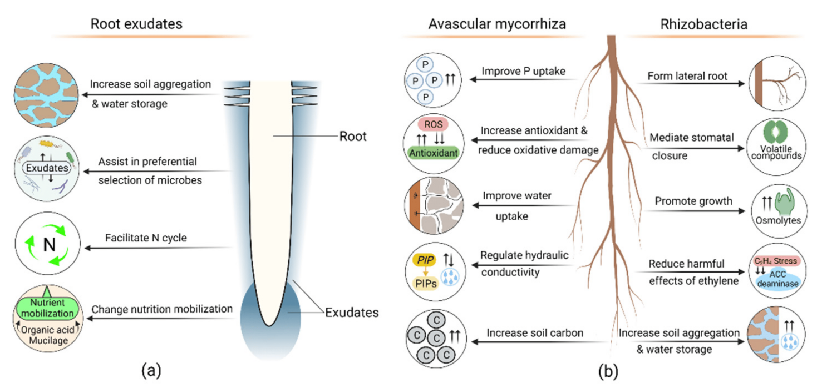

Figure 1 Beneficial roles of root exudates, avascular mycorrhiza (AM), and rhizobacteria in plant drought adaptation (Adopted from Shoaib et al., 2022)

Image caption: (a) Exudates effects soil aggregation, water holding capacity, and nutrient mobilization. The plant preferentially selects microbes through exudation, which assists in drought adaptation. Exudates also influence the soil nitrogen (N) cycle. (b) AM increases phosphorus (P) and water uptake, affecting root hydraulic conductivity and reducing drought stress by producing antioxidants. AM also increases soil carbon. Rhizobacteria release exopolysaccharides, volatile compounds, osmolytes, ACC-deaminase, and phytohormones. These compounds increase soil aggregation, lateral root formation, and plant growth; mediate stomatal closure, reduce ethylene’s harmful effect, and ultimately increase drought resistance (Adopted from Shoaib et al., 2022)

**3.3 Hydraulic redistribution**

Hydraulic redistribution is a process where tree roots transfer water within the soil profile, redistributing it from wetter to drier areas. This phenomenon, also known as "hydraulic lift," allows trees to maintain root viability and facilitate growth in dry soils. For instance, *Grevillea robusta* and *Eucalyptus camaldulensis* have been observed to transport water from deeper soil layers to dry surface horizons, and vice versa, depending on soil moisture conditions (Burgess et al., 1998). This redistribution helps in maintaining water availability in the root zone, especially during dry periods. Additionally, trees can shift water uptake among existing roots rather than growing new ones, as seen in conifers during prolonged droughts (Mackay et al., 2019). This strategy is crucial for sustaining water uptake and ensuring tree survival under adverse conditions.

**4 Drought Adaptation Mechanisms in Tree Roots**

**4.1 Root plasticity and drought response**

Tree roots exhibit significant plasticity in response to prolonged dry conditions, adapting both structurally and functionally to enhance survival. Under drought stress, roots may adjust their biomass, with some species increasing root length and surface area to explore a larger soil volume for water (Brunner et al., 2015; Nikolova et al., 2020). For instance, European beech and Norway spruce show species-specific root adaptations, with beech producing thin, ephemeral fine roots that have high specific root area and respiratory activity, facilitating rapid resource exploitation (Nikolova et al., 2020). Additionally, root system architecture, including the number and length of main and lateral roots, can be remodeled under drought conditions, driven by various phytohormones and signaling pathways (Ranjan et al., 2022).

**4.2 Mycorrhizal associations**

Symbiotic relationships between tree roots and mycorrhizal fungi play a crucial role in improving water uptake efficiency under drought conditions. Arbuscular mycorrhizal fungi (AMF) enhance root morphological traits such as root length, surface area, and volume, which are critical for water absorption (Zou et al., 2017; Chandrasekaran, 2022). These fungi also increase the density and length of root hairs, further aiding in water uptake (Zou et al., 2017). Moreover, mycorrhizal associations can improve root hydraulic conductivity and nutrient acquisition, which indirectly supports better water relations in trees (Lehto and Zwiazek, 2011; Calvo-Polanco et al., 2016). For example, mycorrhizal associations in spruce help maintain high respiratory activity in absorptive roots during drought, indicating a reliance on these symbiotic relationships for drought resistance (Nikolova et al., 2020).

**4.3 Osmotic adjustment and root hydraulics**

Physiological changes in tree roots, such as osmotic adjustment, are vital for retaining water during droughts. Roots can accumulate osmolytes like non-structural carbohydrates, which help maintain cell turgor and protect root tissues from dehydration (Nikolova et al., 2020). Additionally, the expression of aquaporin genes, which regulate water transport across cell membranes, can be modulated under drought conditions to enhance root hydraulic conductivity. For instance, olive plants inoculated with mycorrhizal fungi from different soils showed varied root hydraulic conductivity, highlighting the role of aquaporins in drought adaptation (Calvo-Polanco et al., 2016). These physiological adjustments enable roots to maintain water uptake and sustain tree growth even under prolonged dry conditions.

**5 Ecological Significance of Root-Soil Water Dynamics**

**5.1 Contribution to ecosystem stability**

Tree root systems play a crucial role in maintaining ecosystem resilience during periods of water stress. Roots are capable of various adaptive responses to drought, such as adjusting root biomass, altering anatomical structures, and undergoing physiological acclimations. These adaptations help trees to avoid and tolerate drought stress, thereby supporting the stability of forest ecosystems (Brunner et al., 2015; Kou et al., 2022). For instance, the ability of roots to access deep water sources during drought conditions ensures the continued survival and functioning of trees, which in turn maintains the overall health and stability of the ecosystem (David et al., 2013; Mackay et al., 2019).

**5.2 Tree species-specific adaptations**

Different tree species exhibit unique root-based adaptations to drought conditions. For example, Mediterranean evergreen oaks like *Quercus suber* have a dimorphic root system that allows them to access both shallow and deep water sources, thereby maximizing water uptake during dry periods (David et al., 2013). Similarly, tropical Eucalyptus species develop deep root systems that enable them to tap into deep soil water reserves, which is particularly beneficial during prolonged dry spells (Christina et al., 2017). These species-specific adaptations highlight the diversity of strategies employed by trees to cope with water stress, emphasizing the importance of understanding root dynamics in different ecological contexts (Bourbia et al., 2021; Ranjan et al., 2022).

**5.3 Soil erosion and water conservation**

Tree roots significantly impact soil erosion prevention and soil water retention. The extensive network of fine roots and root hairs increases the soil's structural integrity, reducing the likelihood of erosion (Nirala et al., 2019). Additionally, roots contribute to soil water conservation by enhancing the soil's ability to retain moisture. This is particularly important in preventing soil degradation and maintaining soil health during drought conditions. The role of roots in hydraulic redistribution, where water is moved from wetter to drier soil layers, further aids in maintaining soil moisture levels and supporting plant growth during dry periods (David et al., 2013; Brunn et al., 2022) (Figure 2). This dual function of preventing soil erosion and conserving water underscores the ecological significance of tree root systems in sustaining healthy and resilient ecosystems.

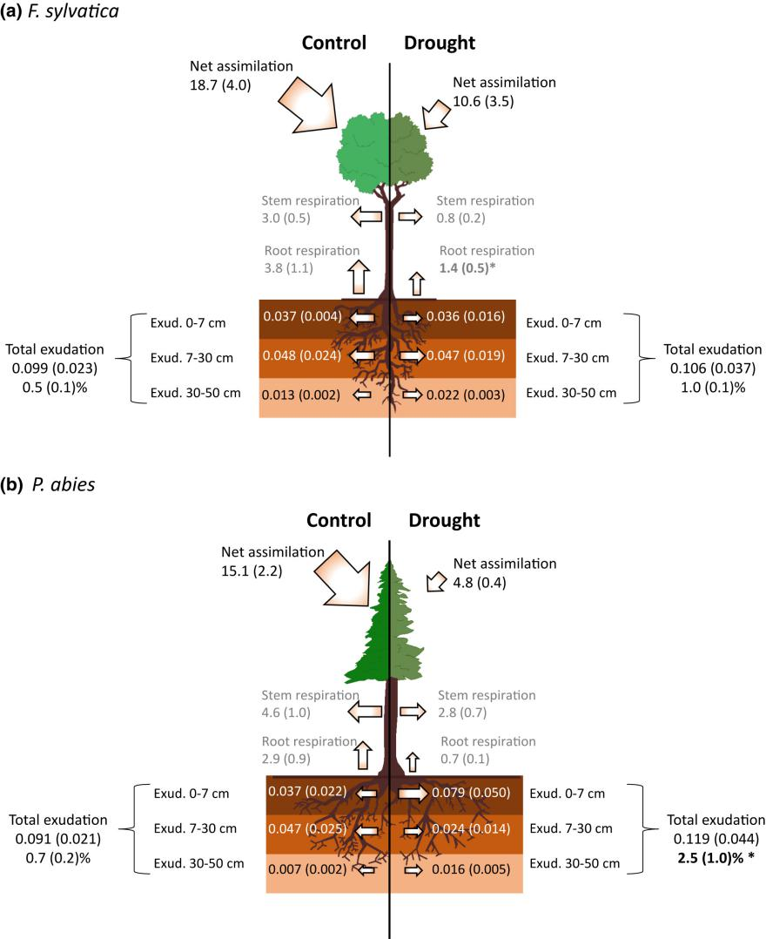

Figure 2 (a, b) Carbon (C) fluxes in Fagus sylvatica (a) and Picea abies (b) on control (left) and drought plots (right) after 5 yr of repeated summer drought. Numbers next to the arrows show C fluxes in g C m−2 plot surface area d−1 (net assimilation, stem respiration, root respiration and root exudation). Respiration fluxes are shown in gray. Numbers next to the roots give the fine-root exudation separated by soil depth increments (dark brown, 0-7 cm; brown, 7-30 cm; light brown, 30-50 cm). Total exudation of the entire rooting zone and the proportion of net-C assimilation allocated to total exudation (assimilation - stem respiration - root respiration; see the section on ‘Assessment of C fluxes and parameters for scaling to the rooting zone and the tree level’ and Supporting Information Methods S1) are given next to the brackets. Note that values for 30-50 cm soil depth were modeled from minirhizotron and soil water content data (see the section on ‘Exudation at the root system and tree level’). Bold numbers and asterisks indicate significant differences (*P* < 0.05) in scaled root respiration and proportion of net assimilation allocated to exudation between control and drought plots. Values are given as means with SEs for n = 3 plots per treatment. All data represent a 2 wk period in early summer (Adopted from Brunn et al., 2022)

**6 Case Studies**

**6.1 Mediterranean tree species**

Mediterranean tree species have evolved unique root structures to adapt to the drought-prone climates characteristic of this region. For instance, the maritime pine (*Pinus pinaster* Ait.) exhibits constitutive drought tolerance mechanisms, with certain genotypes pre-adapted to cope with water stress by expressing stress-related genes even under non-stress conditions. This adaptation is crucial for their survival and performance during recurrent drought periods, which are expected to increase due to climate change (María et al., 2020). Additionally, studies on Mediterranean oak and pine species have shown significant population genetic differentiation in traits related to drought tolerance, suggesting that these species have evolved increased drought tolerance as an adaptation to xeric and warm areas of the Mediterranean climate (Ramírez-Valiente et al., 2021).

**6.2 Tropical forest tree species**

In tropical forests, tree species exhibit diverse root-water dynamics to cope with seasonal droughts. For example, a study on tropical dry forest (TDF) trees identified three functional guilds based on their drought survival mechanisms: drought avoiding, drought resistant, and drought tolerant. These guilds showed significant differences in species richness, stem density, and biomass accumulation capacity across a soil moisture gradient, with drought avoiding species dominating drier sites and drought tolerant species thriving in moister areas (Chaturvedi et al., 2020). Another study highlighted the species-specific impact of drought on root metabolic profiles and carbon allocation pathways in tropical rainforest species, demonstrating different defense mechanisms such as enhanced root structural defense and biochemical defense (Honeker et al., 2022). Furthermore, a meta-analysis of Neotropical humid forests revealed that wood density is a good proxy for predicting leaf- and tree-scale responses to drought, with higher wood density correlating with better drought resistance (Janssen et al., 2020).

**6.3 Arid and semi-arid tree species**

Tree species in arid and semi-arid regions have developed root adaptations to survive extreme drought conditions. For instance, conifers in these regions depend on established roots to access reliable water sources during prolonged droughts. A dynamic root-hydraulic modeling framework showed that trees with root access to bedrock groundwater could maintain non-lethal water potentials by shifting water uptake among existing roots rather than growing new roots during drought (Mackay et al., 2019). Additionally, a study on fine-root dynamics in temperate forest trees under repetitive seasonal droughts found that species-specific responses, such as reduced fine-root production and prolonged root lifespan, play a crucial role in maintaining belowground productivity and root-derived organic matter supply to the soil (Zwetsloot and Bauerle, 2021). These adaptations are essential for the survival and ecological functioning of tree species in arid and semi-arid ecosystems.

**7 Impact of Root Structure on Water Use Efficiency**

**7.1 Water use efficiency mechanisms**

Tree root systems play a crucial role in optimizing water use under limited water availability. The architecture of the root system, including the number and length of main and lateral roots, as well as the density and length of root hairs, exhibits significant plasticity in response to drought conditions. This plasticity allows trees to enhance their water uptake efficiency by adjusting their root growth and development to access deeper soil moisture reserves (Maurel and Nacry, 2020; Ranjan et al., 2022). Additionally, the hydraulic characteristics of roots, such as their ability to adjust water transport capacity, are essential for maintaining water uptake during periods of water scarcity (Vadez, 2014). The coordination between root architecture and leaf-level water use efficiency (WUE) is also critical, as deeper root systems can access stable water sources, thereby supporting higher WUE and reducing drought vulnerability.

**7.2 Role of root architecture in reducing water loss**

Trees employ various strategies to minimize water loss through their root systems. One key strategy is the development of deep root systems that can access groundwater or deep soil moisture, which is less prone to evaporation compared to surface water (Christina et al., 2017; Mackay et al., 2019). This deep rooting not only provides a reliable water source during drought but also reduces the need for frequent water uptake from the upper soil layers, where water loss through evaporation is higher. Additionally, trees can modulate their root hydraulic properties to control water uptake and loss. For instance, by adjusting root hydraulic conductivity, trees can regulate the rate of water transport to the aerial parts, thereby optimizing water use and minimizing unnecessary water loss (Bucci et al., 2009). The ability to shift water uptake among existing roots rather than growing new roots during drought also helps in conserving energy and reducing water loss (Mackay et al., 2019).

**7.3 Root-mediated changes in soil moisture**

Root structures significantly influence overall soil moisture retention during drought. Trees with extensive and deep root systems can enhance soil moisture retention by accessing and utilizing water from deeper soil layers, which helps in maintaining soil moisture levels during dry periods (Christina et al., 2017). Moreover, the presence of roots can improve soil structure and water holding capacity, as roots create channels that facilitate water infiltration and reduce surface runoff. The interaction between roots and soil microbes also plays a role in improving soil moisture retention, as symbiotic relationships can enhance root growth and soil structure, leading to better water retention (Shoaib et al., 2022). In ecosystems with varying rooting depths, species-specific differences in root architecture can lead to distinct soil moisture dynamics, with deep-rooted species maintaining more stable soil moisture levels compared to shallow-rooted species (Bucci et al., 2009).

**8 Influence of Root Structure on Carbon Sequestration**

**8.1 Relationship between root growth and carbon storage**

Deep-rooted species play a crucial role in sequestering carbon and mitigating climate change. These species can access deeper soil layers, which allows them to store carbon more effectively and for longer periods. Deep roots enhance bedrock weathering (Figure 3), which regulates the long-term carbon cycle by connecting deep soil/groundwater to the atmosphere and influencing the hydrologic cycle and climate (Fan et al., 2017). Additionally, deep-rooted trees can improve water and nutrient acquisition, indirectly stimulating photosynthetic CO2 capture and promoting belowground carbon sequestration (Bach and Gojon, 2023). The presence of deep roots in various ecosystems underscores their importance in enhancing ecosystem resilience to environmental stress, such as drought, and in contributing to long-term carbon storage (Pierret et al., 2016).

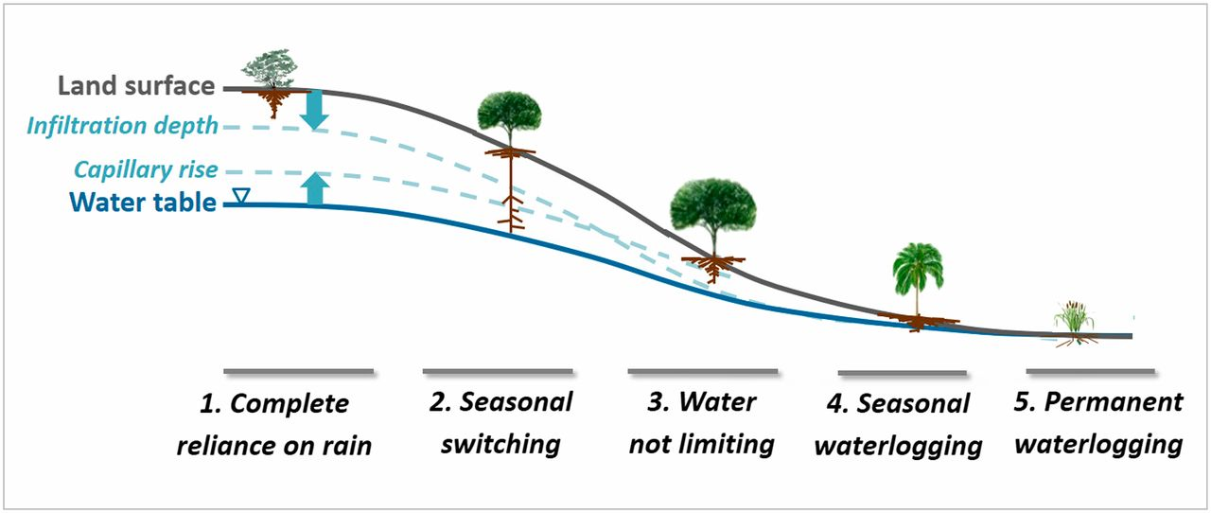

Figure 3 Schematic of soil water profiles along a drainage gradient, wetted from above by rain infiltration and from below by groundwater capillary rise, with a dry gap that diminishes downslope. Along this gradient, plant rooting depths vary systematically (see text). SI Appendix, Fig. S3 gives examples of published root images at different drainage positions (Adopted from Fan et al., 2017)

**8.2 Carbon allocation in drought-stressed trees**

Drought significantly affects carbon allocation in trees, particularly in their root systems. During drought conditions, trees often adjust their root biomass and undergo anatomical and physiological changes to tolerate stress (Brunner et al., 2015). These adjustments can lead to a reduction in carbon sequestration, as observed in studies where drought diminished carbon sequestration by up to 67% despite an increase in water-use efficiency (Martínez-Sancho et al., 2022). Drought also decreases the total non-structural carbohydrates (NSC) in roots, which are essential for energy storage and metabolic processes (Li et al., 2018). This reduction in NSC can impact the overall carbon balance of forest ecosystems, highlighting the need for more research on the belowground responses of trees to drought (Brunner et al., 2015).

**8.3 Soil organic carbon and root-sourced contributions**

Tree root systems contribute significantly to building and maintaining soil organic carbon (SOC) levels. Roots are the primary source of carbon input into soils, and their growth and development are crucial for belowground carbon sequestration (Bach and Gojon, 2023). Mycorrhizal fungi associated with tree roots also play a vital role in soil carbon dynamics. For instance, cord-forming ectomycorrhizal fungi and ericoid mycorrhizal fungi have been shown to influence carbon storage through their effects on fungal tissue turnover and decomposition (Clemmensen et al., 2015). Additionally, drought conditions can reduce soil organic carbon content by decreasing plant litter input and litter decomposition rates, further emphasizing the importance of root systems in maintaining SOC levels (Deng et al., 2021). Understanding the contributions of tree root systems to SOC is essential for predicting long-term soil carbon storage and climate feedbacks in various ecosystems (Clemmensen et al., 2015; Deng et al., 2021).

**9 Challenges and Future Directions**

**9.1 Knowledge gaps in root-soil water interactions**

Despite significant advancements in understanding tree root responses to drought, there remain substantial knowledge gaps, particularly in fine-scale root adaptations. Current research has highlighted the importance of root biomass adjustments, anatomical alterations, and physiological acclimations in drought conditions (Brunner et al., 2015). However, the intricate interactions between fine roots and soil water dynamics, especially under varying degrees of soil moisture, are not fully understood. For instance, the response characteristics of fine roots to different soil drought levels, such as changes in fine-root vertical distribution and morphological traits, need further exploration (Tan et al., 2023). Additionally, the role of root hydraulics and their contribution to water extraction during critical growth stages remains under-researched (Vadez, 2014). Understanding these fine-scale adaptations is crucial for developing comprehensive models of root-soil water interactions and improving predictions of tree responses to climate change.

**9.2 Implications for forest management and conservation**

Insights into root structure and water dynamics can significantly inform forest management and conservation strategies, particularly in the context of increasing drought frequency and intensity. For example, knowledge of how tree roots adjust their vertical distribution and morphological traits in response to soil drought can guide the selection of drought-resistant species and the design of forest stands that are more resilient to water stress (Tan et al., 2023). Additionally, understanding the hydraulic characteristics of roots and their role in water uptake can help in developing management practices that optimize water use during critical growth periods (Vadez, 2014). Forest management strategies can also benefit from recognizing the importance of established root systems in maintaining tree health during prolonged droughts, as trees often rely on existing roots to access deeper water sources rather than growing new roots (Mackay et al., 2019). These insights can lead to more effective conservation practices that enhance the long-term resilience of forest ecosystems to drought.

**9.3 Technological advances in root study**

Emerging tools and methods are revolutionizing the study of root-soil interactions and drought resilience. Advances in imaging technologies, such as minirhizotrons, allow for detailed observation of fine-root dynamics and their responses to environmental stressors over time (Zwetsloot and Bauerle, 2021). Additionally, the development of dynamic root-hydraulic models provides new insights into the feedback mechanisms between root growth, carbon allocation, and soil-plant hydraulics under drought conditions (Mackay et al., 2019). Omics approaches, including genomics, transcriptomics, and proteomics, have significantly enhanced our understanding of the regulatory mechanisms underlying root system architecture and its remodeling under drought stress (Ranjan et al., 2022). These technological advancements are crucial for identifying key traits and regulatory elements that contribute to drought resilience, thereby informing breeding programs and conservation strategies aimed at developing drought-tolerant tree species and forest ecosystems.

**10 Concluding Remarks**

Tree root structures play a pivotal role in influencing soil water dynamics, particularly under drought conditions. Various studies have highlighted the adaptive responses of root traits to water stress, emphasizing the importance of root system architecture (RSA) in drought adaptation. Key root traits such as root depth, root length, root diameter, and root-to-shoot ratio exhibit significant plasticity under water-limited environments, enabling trees to optimize water uptake and maintain physiological functions during drought.

Roots can access deeper soil layers to tap into additional water reserves, which is crucial for sustaining water supply during prolonged dry periods. This deep rooting strategy has been observed in various species, including tropical eucalypt forests and Patagonian woody species, where deep roots provide a buffer against seasonal water deficits. Additionally, the hydraulic characteristics of roots, such as hydraulic conductivity and root hydraulic resistance, are essential for regulating water transport and maintaining plant water status under drought conditions.

Understanding the dynamics of tree root structures and their role in soil water management is critical for ecosystem conservation and forest management strategies. Deep rooting systems enhance the resilience of trees to drought by accessing water from deeper soil layers, which can mitigate the impacts of climate change-induced droughts on forest ecosystems. This knowledge is particularly valuable for the development of drought-tolerant crop varieties and the implementation of sustainable agricultural practices.

In forest management, promoting species with efficient root systems can improve the overall health and stability of forest ecosystems. For instance, selecting tree species with deep rooting capabilities can enhance water uptake during dry periods, thereby supporting forest productivity and reducing the risk of tree mortality during droughts. Additionally, understanding root-soil interactions and the role of root traits in water dynamics can inform reforestation and afforestation projects, ensuring the long-term sustainability of these initiatives.

**Acknowledgments**

We appreciate the feedback from two anonymous peer reviewers on the manuscript of this study.

**Conflict of Interest Disclosure**

The authors affirm that this research was conducted without any commercial or financial relationships that could be construed as a potential conflict of interest.

**References**

Bach L., and Gojon A., 2023. Root system growth and development responses to elevated CO2: underlying signalling mechanisms and role in improving plant CO2 capture and soil C storage.. The Biochemical journal, 480 11, pp. 753-771 . <https://doi.org/10.1042/BCJ20220245.>

Bellini C., Păcurar D., and Perrone I., 2014. Adventitious roots and lateral roots: similarities and differences.. Annual review of plant biology, 65, pp. 639-66 . <https://doi.org/10.1146/annurev-arplant-050213-035645.>

Bourbia I., Pritzkow C., and Brodribb T., 2021. Herb and conifer roots show similar high sensitivity to water deficit.. Plant physiology, 186 4, pp. 1908-1918 . <https://doi.org/10.1093/PLPHYS/KIAB207.>

Brunn M., Hafner B., Zwetsloot M., Weikl F., Pritsch K., Hikino K., Ruehr N., Sayer E., and Bauerle T., 2022. Carbon allocation to root exudates is maintained in mature temperate tree species under drought.. The New phytologist. <https://doi.org/10.1111/nph.18157.>

Brunner I., Herzog C., Dawes M., Arend M., and Sperisen C., 2015. How tree roots respond to drought. Frontiers in Plant Science, 6. <https://doi.org/10.3389/fpls.2015.00547.>

Bucci S., Scholz F., Goldstein G., Meinzer F., and Arce M., 2009. Soil water availability and rooting depth as determinants of hydraulic architecture of Patagonian woody species. Oecologia, 160, pp. 631-641. <https://doi.org/10.1007/s00442-009-1331-z.>

Burgess S., Adams M., Turner N., and Ong C., 1998. The redistribution of soil water by tree root systems. Oecologia, 115, pp. 306-311. <https://doi.org/10.1007/s004420050521.>

Calvo-Polanco M., Sánchez-Castro I., Cantos M., García J., Azcón R., Ruiz-Lozano J., Beuzón C., and Aroca R., 2016. Effects of different arbuscular mycorrhizal fungal backgrounds and soils on olive plants growth and water relation properties under well-watered and drought conditions.. Plant, cell and environment, 39 11, pp. 2498-2514 . <https://doi.org/10.1111/pce.12807.>

Chandrasekaran M., 2022. Arbuscular Mycorrhizal Fungi Mediated Enhanced Biomass, Root Morphological Traits and Nutrient Uptake under Drought Stress: A Meta-Analysis. Journal of Fungi, 8. <https://doi.org/10.3390/jof8070660.>

Chaturvedi R., Tripathi A., Raghubanshi A., and Singh J., 2020. Functional traits indicate a continuum of tree drought strategies across a soil water availability gradient in a tropical dry forest. Forest Ecology and Management, pp. 118740. <https://doi.org/10.1016/j.foreco.2020.118740.>

Christina M., Nouvellon Y., Laclau J., Stape J., Bouillet J., Lambais G., and Maire G., 2017. Importance of deep water uptake in tropical eucalypt forest. Functional Ecology, 31, pp. 509-519. <https://doi.org/10.1111/1365-2435.12727.>

Clemmensen K., Finlay R., Dahlberg A., Stenlid J., Wardle D., and Lindahl B., 2015. Carbon sequestration is related to mycorrhizal fungal community shifts during long-term succession in boreal forests.. The New phytologist, 205 4, pp. 1525-36 . <https://doi.org/10.1111/nph.13208.>

David T., Pinto C., Nadezhdina N., Kurz-Besson C., Henriques M., Quilhó T., Cermak J., Chaves M., Pereira J., and David J., 2013. Root functioning, tree water use and hydraulic redistribution in Quercus suber trees: A modeling approach based on root sap flow. Forest Ecology and Management, 307, pp. 136-146. <https://doi.org/10.1016/J.FORECO.2013.07.012.>

Deng L., Peng C., Kim D., Li J., Liu Y., Hai X., Liu Q., Huang C., Shangguan Z., and Kuzyakov Y., 2021. Drought effects on soil carbon and nitrogen dynamics in global natural ecosystems. Earth-Science Reviews, 214, pp. 103501. <https://doi.org/10.1016/j.earscirev.2020.103501.>

Doussan C., Pierret A., Garrigues E., and Pagès L., 2006. Water Uptake by Plant Roots: II – Modelling of Water Transfer in the Soil Root-system with Explicit Account of Flow within the Root System – Comparison with Experiments. Plant and Soil, 283, pp. 99-117. <https://doi.org/10.1007/s11104-004-7904-z.>

Fan Y., Miguez-Macho G., Jobbágy E., Jackson R., and Otero-Casal C., 2017. Hydrologic regulation of plant rooting depth. Proceedings of the National Academy of Sciences, 114, pp. 10572 - 10577. <https://doi.org/10.1073/pnas.1712381114.>

Fry E., Evans A., Sturrock C., Bullock J., and Bardgett R., 2018. Root architecture governs plasticity in response to drought. Plant and Soil, 433, pp. 189 - 200. <https://doi.org/10.1007/s11104-018-3824-1.>

Henry A., Cal A., Batoto T., Torres R., and Serraj R., 2012. Root attributes affecting water uptake of rice (Oryza sativa) under drought. Journal of Experimental Botany, 63, pp. 4751 - 4763. <https://doi.org/10.1093/jxb/ers150.>

Honeker L., Hildebrand G., Fudyma J., Daber L., Hoyt D., Flowers S., Gil-Loaiza J., Kübert A., Bamberger I., Anderton C., Cliff J., Leichty S., AminiTabrizi R., Kreuzwieser J., Shi L., Bai X., Veličković D., Dippold M., Ladd S., Werner C., Meredith L., and Tfaily M., 2022. Elucidating Drought-Tolerance Mechanisms in Plant Roots through 1H NMR Metabolomics in Parallel with MALDI-MS, and NanoSIMS Imaging Techniques.. Environmental science and technology. <https://doi.org/10.1021/acs.est.1c06772.>

Jackisch C., Knoblauch S., Blume T., Zehe E., and Hassler S., 2019. Estimates of tree root water uptake from soil moisture profile dynamics. Biogeosciences. <https://doi.org/10.5194/bg-2019-466.>

Janssen T., Fleischer K., Luyssaert S., Naudts K., and Dolman H., 2020. Drought resistance increases from the individual to the ecosystem level in highly diverse Neotropical rainforest: a meta-analysis of leaf, tree and ecosystem responses to drought. Biogeosciences, 17, pp. 2621-2645. <https://doi.org/10.5194/BG-17-2621-2020.>

Kinzinger L., Mach J., Haberstroh S., Schindler Z., Frey J., Dubbert M., Seeger S., Seifert T., Weiler M., Orlowski N., and Werner C., 2023. Interaction between Beech and Spruce trees in temperate forests affects water use, root water uptake pattern and canopy structure.. Tree physiology. <https://doi.org/10.1093/treephys/tpad144.>

Kou X., Han W., and Kang J., 2022. Responses of root system architecture to water stress at multiple levels: A meta-analysis of trials under controlled conditions. Frontiers in Plant Science, 13. <https://doi.org/10.3389/fpls.2022.1085409.>

Lehto T., and Zwiazek J., 2011. Ectomycorrhizas and water relations of trees: a review. Mycorrhiza, 21, pp. 71-90. <https://doi.org/10.1007/s00572-010-0348-9.>

Li W., Hartmann H., Adams H., Zhang H., Jin C., Zhao C., Guan D., Wang A., Yuan F., and Wu J., 2018. The sweet side of global change–dynamic responses of non-structural carbohydrates to drought, elevated CO2 and nitrogen fertilization in tree species. Tree Physiology, 38, pp. 1706–1723. <https://doi.org/10.1093/treephys/tpy059.>

Liu Y., Nadezhdina N., Hu W., Clothier B., Duan J., Li X., and Xi B., 2023. Evaporation-driven internal hydraulic redistribution alleviates root drought stress: mechanisms and modeling.. Plant physiology. <https://doi.org/10.1093/plphys/kiad364.>

Mackay D., Savoy P., Grossiord C., Tai X., Pleban J., Wang D., McDowell N., Adams H., and Sperry J., 2019. Conifers depend on established roots during drought: results from a coupled model of carbon allocation and hydraulics.. The New phytologist. <https://doi.org/10.1111/nph.16043.>

María N., Guevara M., Perdiguero P., Vélez M., Cabezas J., López-Hinojosa M., Li Z., Díaz L., Pizarro A., Mancha J., Sterck L., Sánchez-Gómez D., Miguel C., Collada C., Díaz-Sala M., and Cervera M., 2020. Molecular study of drought response in the Mediterranean conifer Pinus pinaster Ait.: Differential transcriptomic profiling reveals constitutive water deficit-independent drought tolerance mechanisms. Ecology and Evolution, 10, pp. 9788 - 9807. <https://doi.org/10.1002/ece3.6613.>

Martínez-Sancho E., Treydte K., Lehmann M., Rigling A., and Fonti P., 2022. Drought impacts on tree carbon sequestration and water use – evidence from intra-annual tree‐ring characteristics. The New Phytologist, 236, pp. 58 - 70. <https://doi.org/10.1111/nph.18224.>

Maurel C., and Nacry P., 2020. Root architecture and hydraulics converge for acclimation to changing water availability. Nature Plants, 6, pp. 744 - 749. <https://doi.org/10.1038/s41477-020-0684-5.>

Nikolova P., Bauerle T., Häberle K., Blaschke H., Brunner I., and Matyssek R., 2020. Fine-Root Traits Reveal Contrasting Ecological Strategies in European Beech and Norway Spruce During Extreme Drought. Frontiers in Plant Science, 11. <https://doi.org/10.3389/fpls.2020.01211.>

Nirala D., Pant N., and Rawat M., 2019. Response of tree roots to drought condition: A review. International Journal of Chemical Studies, 7, pp. 824-826.

Pierret A., Maeght J., Clément C., Montoroi J., Hartmann C., and Gonkhamdee S., 2016. Understanding deep roots and their functions in ecosystems: an advocacy for more unconventional research.. Annals of botany. <https://doi.org/10.1093/AOB/MCW130.>

Ramírez-Valiente J., Blanco L., Alía R., Robledo-Arnuncio J., and Climent J., 2021. Adaptation of Mediterranean forest species to climate: Lessons from common garden experiments. Journal of Ecology, 110, pp. 1022 - 1042. <https://doi.org/10.1111/1365-2745.13730.>

Ranjan A., Sinha R., Singla-Pareek S., Pareek A., and Singh A., 2022. Shaping the Root System Architecture in Plants for Adaptation to Drought Stress.. Physiologia plantarum, pp. e13651 . <https://doi.org/10.1111/ppl.13651.>

Shoaib M., Banerjee B., Hayden M., and Kant S., 2022. Roots’ Drought Adaptive Traits in Crop Improvement. Plants, 11. <https://doi.org/10.3390/plants11172256.>

Tan J., Yu W., Liu Y., Guo Y., Liu N., Fu H., Di N., Duan J., Li X., and Xi B., 2023. Response of Fine-Root Traits of Populus tomentosa to Drought in Shallow and Deep Soil. Forests. <https://doi.org/10.3390/f14050951.>

Vadez V., 2014. Root hydraulics: The forgotten side of roots in drought adaptation. Field Crops Research, 165, pp. 15-24. <https://doi.org/10.1016/J.FCR.2014.03.017.>

Zou Y., Wang P., Liu C., Ni Q., Zhang D., and Wu Q., 2017. Mycorrhizal trifoliate orange has greater root adaptation of morphology and phytohormones in response to drought stress. Scientific Reports, 7. <https://doi.org/10.1038/srep41134.>

Zwetsloot M., and Bauerle T., 2021. Repetitive seasonal drought causes substantial species-specific shifts in fine-root longevity and spatio-temporal production patterns in mature temperate forest trees.. The New phytologist. <https://doi.org/10.1111/nph.17432.>

**Disclaimer/Publisher's Note**

The statements, opinions, and data contained in all publications are solely those of the individual authors and contributors and do not represent the views of the publishing house and/or its editors. The publisher and/or its editors disclaim all responsibility for any harm or damage to persons or property that may result from the application of ideas, methods, instructions, or products discussed in the content. Publisher remains neutral with regard to jurisdictional claims in published maps and institutional affiliations.