Research insight

**Research on the Influence of Cultivation Environment on the Active Ingredient Content and Physiological Response of Tongzi Yimicao**

Jiayao Zhou *, Hongpeng Wang

Traditional Chinese Medicine Research Center, Cuixi Academy of Biotechnology, Zhuji, 311800, China

*Corresponding author, jiayao.zhou@cuixi.org

**Abstract** This study focuses on the effects of different cultivation conditions on the content of active ingredients and plant physiological changes in *Leonurus japonicus*. Tongzi Yimucao is a commonly used herbal plant in traditional Chinese medicine, commonly used to treat gynecological diseases. Its main active substances are leonurine and carnosine. Several factors in the cultivation environment can directly affect the synthesis and accumulation process of these components. In terms of water management, appropriate drought treatment can induce plants to accumulate more flavonoids and phenolic acids. Strong light conditions can stimulate laser interaction, indirectly enhancing the accumulation of active ingredients; Moderate temperature helps plants maintain metabolic balance, while too high or too low temperature may inhibit the synthesis of metabolites. Modern cultivation methods such as greenhouse planting and hydroponic technology can achieve more precise regulation of these environmental factors. Under controlled conditions, plant growth is more stable and the fluctuation of active ingredients is smaller. Environmental stress can cause changes in the antioxidant enzyme system within plants, such as increased activity of superoxide dismutase (SOD) and catalase (CAT). This type of reaction varies under different cultivation conditions, so it is necessary to design reasonable management measures in actual production. Future research can further combine precision agriculture equipment and molecular biology methods to reveal the relationship between environment and components at the genetic level, explore better cultivation schemes, and improve the quality and efficacy of *Leonurus japonicus*.

**Keywords** *Leonurus japonicus*; Active compounds; Environmental factors; Cultivation techniques; Physiological response

**1 Introduction**

*Leonurus japonicus*, also known as Chinese motherwort, is a traditional Chinese medicinal herb mainly used to treat common female diseases. Its main active ingredients are leonurine and carnosine, which have anti-inflammatory, heart protective, and antioxidant effects (Shang et al., 2014). In addition to its traditional use, it may have anti-cancer, hepatoprotective, and neuroprotective effects (Miao et al., 2019).

The active ingredients contained in this plant are influenced by the growth environment, such as soil acidity, light intensity, and temperature. The slightly alkaline soil conditions are favorable for the generation of alkaloids such as sage alkaloids, as they can promote the activity of related synthetic pathways (Zhang et al., 2022; Feng, 2024). In the context of global climate change, understanding the response mechanism of *Leonurus japonicus* to environmental changes, maintaining its medicinal value, and ensuring yield.

This study will focus on how environmental conditions affect the synthesis of the active ingredients of *Leonurus japonicus*, focusing on the effects of factors such as soil composition, pH, temperature and light on the production of leonurine and caryophylline, and exploring the physiological response mechanisms of plants under these conditions. It is hoped that this will provide guidance for the scientific cultivation of *Leonurus japonicus*, improve its yield and quality, and provide a reference basis for subsequent research and medicinal material production.

**2 Active Components of *Leonurus japonicus***

**2.1 Main chemical components: flavonoids, phenolic acids, alkaloids, and essential oils**

*Leonurus japonicus* contains a variety of active substances. This plant's main components include flavonoids, phenols, alkaloids, diterpenes, and volatile essential oils (Figure 1) (Miao et al., 2019). Leonurine and carnosine are alkaloids that have been most extensively studied and are highly regarded for their significant pharmacological effects. Flavonoids, such as rutin and some flavonoid derivatives, can combat free radicals in the body. Phenolic compounds, such as rosmarinic acid, have certain anti-inflammatory and antioxidant activities (Shang et al., 2014). The essential oil extracted from *Leonurus japonicus* is primarily composed of monoterpenes and sesquiterpenes, which exhibit antibacterial and anti-inflammatory properties (Xiong et al., 2013).

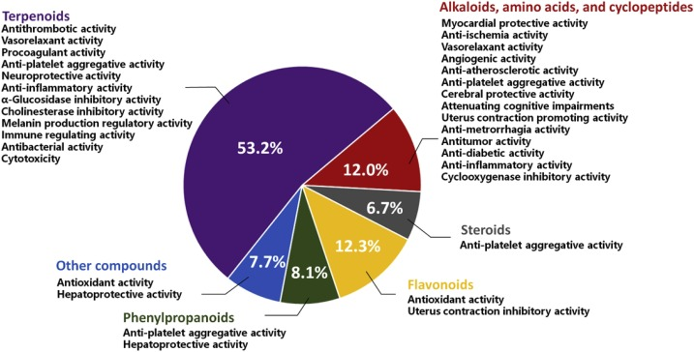

Figure 1 Activities and proportions of six types of compounds isolated from *L. japonicus* (Adopted from Miao et al., 2019)

The amount of these components will be affected by external conditions. When the soil is neutral or slightly alkaline, leonurine is formed (Zhang et al., 2022). The intensity of sunlight will also change the accumulation of flavonoids and phenolic acids, and the light conditions of artificial planting must be well controlled (Mertens et al., 2016; Zhou and memelink, 2016).

**2.2 Pharmacological effects of active ingredients**

Compounds in *Leonurus japonicus* have been shown to have multiple medicinal properties. The most important is leonurine, which can induce uterine contractions and is used to regulate menstrual irregularities and postpartum recovery (Liu et al., 2018). It also improves endothelial function, reduces oxidative damage, and has a protective effect on the heart (Shang et al., 2014).

Flavones and phenolic compounds can neutralize free radicals and reduce the production of inflammatory factors, such as tumor necrosis factor alpha (TNF-α) and certain interleukins (Miao et al., 2019). The essential oil also has significant antibacterial properties, particularly against Gram-positive bacteria, and is used to treat some infections (Xiong et al., 2013).

**2.3 Clinical uses of active ingredients**

These ingredients have been widely used in practical medication. In traditional Chinese medicine, leonurine and carnosine are often used to treat gynecological problems such as dysmenorrhea and amenorrhea. They can promote uterine blood flow, regulate contractions, and also help with postpartum repair (Shang et al., 2014). Some modern drugs are also developing and utilizing these alkaline components to dilate blood vessels and relieve pressure on the cardiovascular system (Miao et al., 2019; Li et al., 2022).

Flavones and essential oil extracts are being used in cosmetics and dermatological applications. Because they can slow oxidation and reduce skin inflammation, these extracts are now included in some skincare products. The antibacterial properties of essential oils are also used to treat acne and other skin infections (Xiong et al., 2013; Du et al., 2020).

**3 Effects of Cultivation Environment on the Content of Active Components in *Leonurus japonicus***

**3.1 Effects of soil type and nutrients**

The active substances in *Leonurus japonicus*, especially carnosine, are significantly affected by soil type and composition. Moderate or slightly alkaline soil acidity is beneficial for nitrogen metabolism in plants, thereby promoting the synthesis of nitrogen-containing compounds such as sage alkaloids (Cheng et al., 2022; Zhang et al., 2022). In addition, trace elements such as manganese, copper, and zinc have a positive effect on alkaloid synthesis, and appropriate supplementation of these elements can improve the level of medicinal components in plants (Shen et al., 2002; Tian et al., 2021; Jiao et al., 2022).

The organic matter in the soil provides continuous nutrients for plants and contributes to the accumulation of flavonoids and phenolic substances. Applying compost or organic fertilizer can enhance the content of these components and improve the antioxidant capacity of plants (Xu, 2006).

**3.2 Effects of climatic conditions (temperature, humidity, and light)**

Temperature, humidity, and light intensity are directly related to the formation of effective substances in *Leonurus japonicus*. When the daytime temperature is between 20 ℃ and 30 ℃, the photosynthetic efficiency of plants is higher, which is conducive to the synthesis of photosynthetic pigments and secondary metabolites such as flavonoids and alkaloids (Shang et al., 2014). Excessive or insufficient temperature can inhibit metabolic activity and lower the levels of active ingredients.

The stronger the light intensity, the higher the synthesis ability of flavonoids and phenolic acids, which helps to enhance antioxidant performance. However, excessive light exposure can easily generate oxidative stress, which can actually affect plant health (Shen et al., 2002; He et al., 2018). Humidity can also affect the formation of active ingredients. Appropriate air humidity is beneficial for the accumulation of essential oils and alkaloids, while excessive dryness or humidity can lower their quality (Tan et al., 2018).

**3.3 Effects of water and fertilizer management**

Excessive watering can dilute the active ingredients, while moderate drought stress can stimulate the plant to synthesize more alkaloids, a typical defense response (Shen et al., 2002). Maintaining stable soil moisture promotes root development, improves nutrient absorption efficiency, and has a positive effect on the production of active ingredients (Xu, 2006).

The method of fertilization is equally crucial. Moderate application of nitrogen fertilizer can increase the content of nitrogen-containing alkaloids such as leonurine and carnosine. However, excessive nitrogen fertilizer can inhibit the accumulation of flavonoids and phenols, so fertilization needs to be balanced (Kuchta et al., 2013). The combination of organic and inorganic fertilizers has the best effect, promoting plant growth and increasing the content of medicinal ingredients (Xu, 2006).

**4 Physiological Responses of *Leonurus japonicus* to Environmental Stress**

**4.1 Effects of environmental stress on the growth of *Leonurus japonicus***

When *Leonurus japonicus* is under environmental stress, its growth will be significantly worse. During drought, the leaves of the plant will become smaller and the stem will not grow high, so the whole plant will grow slowly. Because water shortage affects its photosynthetic efficiency, the ability of plants to absorb and use water decreases (Shang et al., 2014).

Excessively high or low temperatures can also disrupt plant metabolism, weakening enzyme activity, damaging cells, reducing plant vitality, and delaying flowering (Zhang et al., 2022). This can affect the harvest time and quality of the medicinal material.

If the soil lacks nutrients such as nitrogen, phosphorus, and potassium, *Leonurus japonicus*'s root system will likely develop poorly, and its leaves will become lighter in color. This is due to reduced chlorophyll synthesis and decreased photosynthetic efficiency. Appropriate nutritional supplementation can alleviate these problems and help plants return to normal growth (Xu, 2006).

**4.2 Effects of environmental stress on the active components of *Leonurus japonicus***

*Leonurus japonicus* will adjust the metabolic process in the body and change the synthesis of some medicinal ingredients in adversity. Drought will promote plants to produce more secondary metabolites, such as carnosine and leonurine (Shen et al., 2002). Plants will use more resources to synthesize defense substances rather than continue to grow (Rong et al., 2022).

If temperatures are too high or drought persists for too long, some plant enzymes, such as those responsible for synthesizing flavonoids and phenolic acids, become inactive. These substances inherently have antioxidant properties, and a decrease in their levels can also reduce plant resistance (Miao et al., 2019). Nitrogen deficiency can also reduce alkaloid synthesis (Xie et al., 2019).

**4.3 Antioxidant changes in *Leonurus japonicus* under environmental stress**

Under stressful conditions, Leonurus chinensis activates its antioxidant system to combat reactive oxygen species (ROS) generated by the harsh environment. Under drought and high temperatures, plants produce large amounts of superoxide anions and hydrogen peroxide, which damage cell membranes. Leonurus chinensis increases the activity of antioxidant enzymes such as superoxide dismutase (SOD), catalase (CAT), and peroxidase (POD) (Shang et al., 2014).

In addition to these enzymes, it also produces non-enzymatic antioxidants such as flavonoids and phenolic acids. These substances can scavenge ROS in the body. Flavonoid production increases significantly during periods of water shortage (Cha, 2021).

**5 Cultivation Techniques and Environmental Control for *Leonurus japonicus***

**5.1 The difference between greenhouse and open-field cultivation**

When *Leonurus japonicus* is grown in a greenhouse, temperature, humidity, and light intensity can be manually controlled, which helps increase the content of medicinal ingredients such as carnosine and leonurine. The greenhouse environment is more stable, the plants are less susceptible to external influences, and pests and diseases are less common, resulting in more reliable yield and quality (Xu, 2006).

In contrast, open-field cultivation is significantly affected by weather, such as temperature fluctuations, heavy rain, and drought, which can affect yield and quality. Although open-field cultivation is cost-effective and suitable for large-scale operations, its active ingredients are less stable. The choice of cultivation method should be determined based on cost and target quality (Shen et al., 2002).

**5.2 The role of environmental control in cultivation (climate and light)**

In order to make *Leonurus japonicus* grow better, many growers now use automatic control equipment to adjust temperature and humidity, which can avoid the impact of extreme weather and reduce the problem of water shortage (Zhang et al., 2022). The automatic irrigation system can also save water and make cultivation more efficient.

In terms of lighting, some greenhouses will be equipped with LED lights or shading equipment to control the intensity and duration of light, regulate the photosynthesis of plants, and promote the production of some important components such as flavonoids and phenolic acids. Changing the wavelength of light can also affect the metabolism of plants and improve the efficacy (Miao et al., 2019).

**5.3 Effects of hydroponics on *Leonurus japonicus***

Hydroponics is a soil-free cultivation method where plants absorb nutrients directly from the nutrient solution. This method allows for more precise control of nutrient content and reduces soil-borne disease risks, promoting rapid plant growth and increasing the content of medicinal ingredients (Tan et al., 2018).

Hydroponic systems use less water, are less prone to soil-borne diseases, and are environmentally friendly. However, this method requires high initial investment and technical skills. Nevertheless, it is still a high-quality cultivation method worth trying and is suitable for production needs that require stable yield and quality (Zhang et al., 2023).

**6 Case Studies and Experimental Findings on *Leonurus japonicus***

**6.1 Domestic and international research on the impact of environmental factors on *Leonurus japonicus***

Environmental conditions have a great influence on the growth and medicinal components of *Leonurus japonicus*. In China, the pH of soil can regulate the synthesis of alkaloids. In neutral or slightly alkaline soils, the nitrogen metabolism of plants is smoother, and the content of active ingredients such as carnosine is also higher (Zhang et al., 2022). Cha (2021) pointed out that the activity of some enzymes in plants will increase under stress, which can improve the synthesis ability of antioxidants and the stress tolerance of plants (Figure 2).

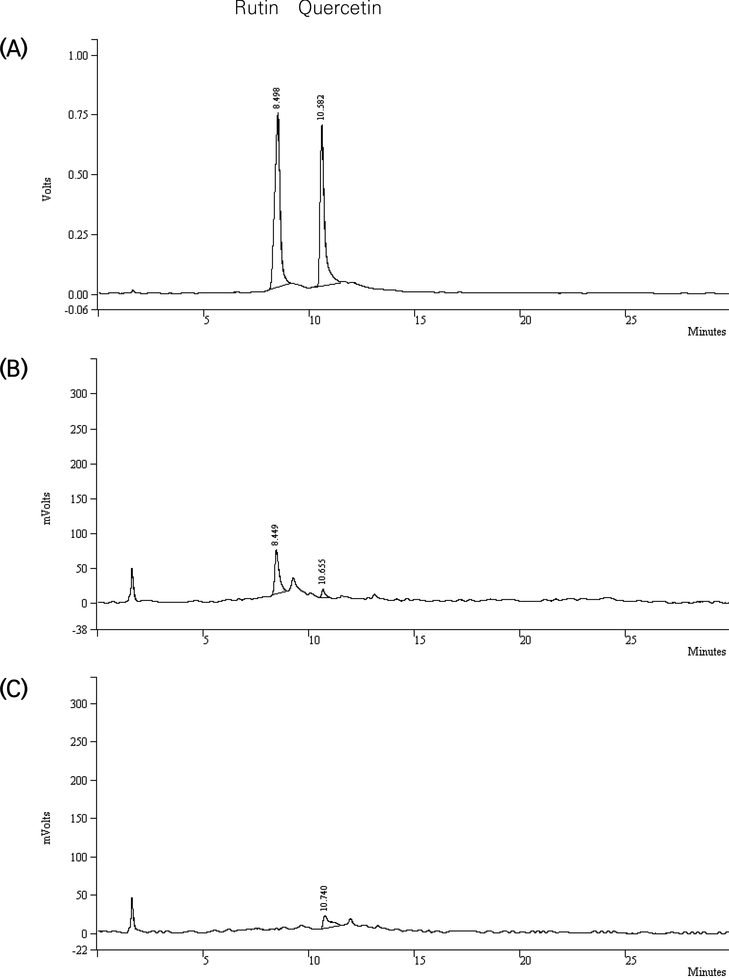

Figure 2 (A) HPLC chromatogram of rutin and quercetin, (B) HPLC chromatography of MeOH extract of Leonurus japonicus Houttuyn, (C) HPLC chromatogram of viscozyme (1%, 24 hr) reaction product of Leonurus japonicus Houttuyn (Adopted from Cha, 2021)

International research has focused on the role of light and temperature. Miao et al. (2019) in Japan found that increasing light intensity during the critical growth period significantly increased the content of flavonoids and phenolic acids, enhancing the antioxidant properties of the plant. Kuchta et al. (2013) in Europe noted that climate instability can affect the synthesis of secondary metabolites in Leonurus chinensis, and maintaining stable environmental conditions can stabilize yield.

**6.2 Findings from laboratory and field trials**

Tan et al. (2018) conducted hydroponic experiments showing that varying nutrient concentrations affect the levels of carnosine and leonurine. When water stress is mild, flavonoid production increases, presumably as a stress response (Shen et al., 2002).

Xu et al. (2006) conducted research in China showing that well-drained, nutrient-rich soil and appropriate light conditions can increase the yield and active ingredient content of Leonurus viridis. Furthermore, Shang et al. (2014) conducted comparative field trials in Vietnam, finding that under moderate humidity and stable temperature conditions, plant secondary metabolites are more stable, with less fluctuation and better quality assurance.

**6.3 Practical application of environmental control technology in *Leonurus japonicus* cultivation**

In order to improve the yield and efficacy, many growers began to use environmental control technology to plant *Leonurus japonicus*. The greenhouse system can automatically control temperature and humidity, provide a constant growth environment, and is helpful for the stable production of carnitine (Xu, 2006). In terms of lighting, dimming led system is used to provide light of specific wavelength and promote flavonoid synthesis in the critical period of growth (Miao et al., 2019).

Hydroponic system can accurately allocate nutrients, avoid uncertain factors brought by soil, improve plant quality, and have higher content of active ingredients (Tan et al., 2018). This method is especially suitable for promotion in cities or areas with limited resources to solve the problem of Limited traditional planting conditions.

**7 Challenges and Future Directions in *Leonurus japonicus* Research**

**7.1 Problems with current cultivation techniques**

Currently, the most common problem encountered in cultivating *Leonurus japonicus* is the unstable yield of its medicinal ingredients (such as carnosine and leonurine). This is primarily due to the high volatility of weather, especially when cultivated outdoors, which is more susceptible to factors such as temperature and rainfall, making it difficult to guarantee yield and quality. Unpredictable weather, severe insect pests, and insufficient soil nutrients all directly affect the plant's normal growth and the accumulation of its active ingredients (Xu, 2006). Currently, many cultivation methods lack standardized procedures, and practices vary greatly among farmers in different locations, resulting in varying quality of the medicinal material.

Although some modern cultivation methods, such as greenhouse planting and hydroponics, can better control temperature and humidity, they are expensive and require high technology. It is difficult for small farmers with insufficient funds and immature technology to afford these advanced systems. Moreover, there are few technical training opportunities in rural areas, and it is not easy to shift from traditional planting to modern technology (Shang et al., 2014).

**7.2 The influence of environmental factors on active ingredients is complex**

It is difficult to clarify the relationship between the active ingredients of *Leonurus japonicus* and environmental conditions. For example, mild drought can sometimes promote an increase in flavonoids and phenolic acids, but if the drought is too severe, it may slow down the overall metabolism of plants, which is not conducive to component accumulation (Shen et al., 2002).

The intensity and color of light have significant effects on plants at different growth stages and under different environments (Miao et al., 2019). These external conditions not only act independently but also interact with each other. Soil pH affects a plant's ability to absorb nutrients and influence the synthesis of alkaline compounds, which is further influenced by temperature and light intensity (Zhang et al., 2022).

**7.3 Research priorities and emerging technologies**

Future research should focus on understanding how *Leonurus japonicus* regulates genes and synthesizes active ingredients in various environments. Transcriptome and metabolomics techniques can be used to identify which genes are active and which metabolic pathways are regulated in plants under different conditions, providing a basis for the subsequent breeding of more stress resistant and yield stable varieties (Miao et al., 2019).

At the technical level, precision agriculture tools can be considered, such as using intelligent sensors to monitor environmental changes such as temperature, humidity, and light, and then automatically control irrigation and fertilization systems to ensure that plants are in the most suitable growth state. The Internet of Things (IoT) technology can already achieve these functions, and if combined with agricultural systems, it can improve yield stability and save resources more (Tan et al., 2018; Zhong, 2024).

In addition, we can continue to optimize hydroponic and gas culture technologies, strive to reduce costs, and enable more farmers to afford and use these technologies, thereby promoting the modernization and industrialization of the cultivation of *Leonurus japonicus*.

**8 Conclusion**

The effective components of *Leonurus japonicus* are affected by a variety of environmental conditions, including soil types, nutrient levels, temperature, light intensity and water management. Appropriate soil pH and adequate nutrition can promote the synthesis of salvianine and other alkaloids. If the light is too strong or the water is insufficient, the plants will be stressed and the accumulation of flavonoids and phenolic acids will be affected.

In order to improve its medicinal effect, it is necessary to control the environmental conditions in the process of planting. Controlled systems such as greenhouse and hydroponics can adjust factors such as light, water and nutrition. These systems can reduce the adverse effects of changes in the natural environment, improve the yield and efficacy, and meet the needs of traditional Chinese medicine and modern drug development.

Future research recommends the introduction of more advanced technologies, such as precision agriculture, IoT monitoring devices, and gene expression analysis, to more precisely control the growing environment of *Leonurus japonicus*. Low-cost, scalable, and small-scale hydroponic equipment should be developed for use by small-scale growers. Further research into how different environmental factors influence the synthesis of active ingredients will facilitate the breeding of new varieties with greater stress resistance and enhanced efficacy.

**Acknowledgments**

I would like to thank XX continuous support throughout the development of this study.

**Conflict of Interest Disclosure**

The authors affirm that this research was conducted without any commercial or financial relationships that could be construed as a potential conflict of interest.

**References**

**参考文献**

Cha, B. (2021). Study on the Change of Antioxidant Activity by Enzymatic Hydrolysis in Sophora japonica Linne, Houttuynia cordata Thunberg, Leonurus japonicus Houttuyn. Journal of Korean Medicine for Obesity Research. <https://doi.org/10.15429/jkomor.2021.21.1.1>

Cheng, F., Zhou, Y., Wang, M., Guo, C., Cao, Z., Zhang, R., & Peng, C. (2020). A review of pharmacological and pharmacokinetic properties of stachydrine.. Pharmacological research, 104755 . <https://doi.org/10.1016/j.phrs.2020.104755>

Du, B., Zhang, X., Shi, N., Peng, T., Gao, J., Azimova, B., Zhang, R., Pu, D., Wang, C., Abduvaliev, A., Rakhmanov, A., Zhang, G., Xiao, W., & Wang, F. (2020). Luteolin-7-methylether from Leonurus japonicus inhibits estrogen biosynthesis in human ovarian granulosa cells by suppression of aromatase (CYP19).. European journal of pharmacology, 173154 . <https://doi.org/10.1016/j.ejphar.2020.173154>

Feng X.Z., 2024, Genetic and environmental factors influencing grain quality in maize, Maize Genomics and Genetics, 15(2): 93-101 (doi: 10.5376/mgg.2024.15.0010)

He, Y., Shi, J., Peng, C., Hu, L., Liu, J., Zhou, Q., Guo, L., & Xiong, L. (2018). Angiogenic effect of motherwort (Leonurus japonicus) alkaloids and toxicity of motherwort essential oil on zebrafish embryos.. Fitoterapia, 128, 36-42 . <https://doi.org/10.1016/j.fitote.2018.05.002>

Jian-Zhong, X. (2006). Study on Cultivation Technique of GAP of Leonurus japonicus

Jiao, C., Wei, M., Fan, H., Song, C., Wang, Z., Cai, Y., & Jin, Q. (2022). Transcriptomic analysis of genes related to alkaloid biosynthesis and the regulation mechanism under precursor and methyl jasmonate treatment in Dendrobium officinale. Frontiers in Plant Science, 13. <https://doi.org/10.3389/fpls.2022.941231>

Kuchta, K., Volk, R., & Rauwald, H. (2013). Stachydrine in Leonurus cardiaca, Leonurus japonicus, Leonotis leonurus: detection and quantification by instrumental HPTLC and 1H-qNMR analyses.. Die Pharmazie, 68 7, 534-40

Li, J., Li, Y., Dang, M., Li, S., Chen, S., Liu, R., Zhang, Z., Li, G., Zhang, M., Yang, D., Yang, M., Liu, Y., Tian, D., & Deng, X. (2022). Jasmonate-Responsive Transcription Factors NnWRKY70a and NnWRKY70b Positively Regulate Benzylisoquinoline Alkaloid Biosynthesis in Lotus (Nelumbo nucifera). Frontiers in Plant Science, 13. <https://doi.org/10.3389/fpls.2022.862915>

Li, C., , Y., Liu, Y., Li, H., Gu, J., & Peng, G. (2017). [Optimize concentrate process of alkaloid from Leonurus japonicus by ultrafultration-nanofiltration coupling technology].. Zhongguo Zhong yao za zhi = Zhongguo zhongyao zazhi = China journal of Chinese materia medica, 42 1, 100-106 . <https://doi.org/10.19540/j.cnki.cjcmm.20161222.057>

Liu, J., Peng, C., Zhou, Q., Guo, L., Liu, Z., & Xiong, L. (2018). Alkaloids and flavonoid glycosides from the aerial parts of Leonurus japonicus and their opposite effects on uterine smooth muscle.. Phytochemistry, 145, 128-136 . <https://doi.org/10.1016/j.phytochem.2017.11.003>

Mertens, J., Van Moerkercke, A., Vanden Bossche, R., Pollier, J., & Goossens, A. (2016). Clade IVa Basic Helix-Loop-Helix Transcription Factors Form Part of a Conserved Jasmonate Signaling Circuit for the Regulation of Bioactive Plant Terpenoid Biosynthesis.. Plant & cell physiology, 57 12, 2564-2575 . <https://doi.org/10.1093/PCP/PCW168>

Miao, L., Zhou, Q., Peng, C., Liu, Z., & Xiong, L. (2019). Leonurus japonicus (Chinese motherwort), an excellent traditional medicine for obstetrical and gynecological diseases: A comprehensive overview.. Biomedicine & pharmacotherapy = Biomedecine & pharmacotherapie, 117, 109060 . <https://doi.org/10.1016/j.biopha.2019.109060>

Rong, W., Li, J., Wang, L., Luo, S., Liang, T., Qian, X., Zhang, X., Zhou, Q., Zhu, Y., & Zhu, Q. (2022). Investigation of the protective mechanism of leonurine against acute myocardial ischemia by an integrated metabolomics and network pharmacology strategy. Frontiers in Cardiovascular Medicine, 9. <https://doi.org/10.3389/fcvm.2022.969553>

Shang, X., Pan, H., Wang, X., He, H., & Li, M. (2014). Leonurus japonicus Houtt.: ethnopharmacology, phytochemistry and pharmacology of an important traditional Chinese medicine.. Journal of ethnopharmacology, 152 1, 14-32 . <https://doi.org/10.1016/j.jep.2013.12.052>

Shen, X., Sheng, S., & Xu, J. (2002). Effect of environmental factors on the total alkaloid content in Yimu Cao (Leonurus artemisia S.Y.Hu)

Tan, Y., Zhou, G., Guo, S., Yan, H., Zhang, J., Zhu, Z., Shi, X., Yue, S., Tang, Y., Huang, S., Peng, G., & Duan, J. (2018). Simultaneous optimization of ultrasonic-assisted extraction of antioxidant and anticoagulation activities of compounds from Leonurus japonicus Houtt. by response surface methodology. RSC Advances, 8, 40748 - 40759. <https://doi.org/10.1039/C8RA07361A>

Tian, Z., Liu, F., Peng, F., He, Y., Shu, H., Lin, S., Chen, J., Peng, C., & Xiong, L. (2021). New lignans from the fruits of Leonurus japonicus and their hepatoprotective activities.. Bioorganic chemistry, 115, 105252 . <https://doi.org/10.1016/j.bioorg.2021.105252>

Xie, Z., Nolan, T., Jiang, H., & Yin, Y. (2019). AP2/ERF Transcription Factor Regulatory Networks in Hormone and Abiotic Stress Responses in Arabidopsis. Frontiers in Plant Science, 10. <https://doi.org/10.3389/fpls.2019.00228>

Xiong, L., Peng, C., Zhou, Q., Wan, F., Xie, X., Guo, L., Li, X., He, C., & Dai, O. (2013). Chemical Composition and Antibacterial Activity of Essential Oils from Different Parts of Leonurus japonicus Houtt.. Molecules, 18, 963 - 973. <https://doi.org/10.3390/molecules18010963>

Zhang, L., Khoo, C., Xiahou, Z., Reddy, N., Li, Y., Lv, J., Sun, M., Fan, H., & Zhang, X. (2023). Antioxidant and anti-melanogenesis activities of extracts from Leonurus japonicus Houtt.. Biotechnology & genetic engineering reviews, 1-22 . <https://doi.org/10.1080/02648725.2023.2202544>

Zhang, Y., Cui, X., Wang, W., Hou, J., & Yan, B. (2022). [Effects of pH value on stachydrine biosynthesis of hydroponic Leonurus japonicus and its physiological mechanism].. Zhongguo Zhong yao za zhi = Zhongguo zhongyao zazhi = China journal of Chinese materia medica, 47 20, 5502-5507 . <https://doi.org/10.19540/j.cnki.cjcmm.20220712.101>

Zhou, M., & Memelink, J. (2016). Jasmonate-responsive transcription factors regulating plant secondary metabolism.. Biotechnology advances, 34 4, 441-449 . <https://doi.org/10.1016/j.biotechadv.2016.02.004>

Zhong J.L., 2024, Discovering genes that enhance yield in drought conditions within turkish winter wheat, Triticeae Genomics and Genetics, 15(3): 121-124 (doi: 10.5376/tgg.2024.15.0012)